**UNIVERSITI TUNKU ABDUL RAHMAN**

**FACULTY OF INFORMATION AND COMMUNICATION TECHNOLOGY**

**UCCD 2223 Website Design and Development**

**Title: Fruit Havana**

**Group name: Chinese Alibaba**

**URL: https://test19365.azurewebsites.net/**

|  |  |  |  |
| --- | --- | --- | --- |
| **Name** | **ID** | **Practical Group** | **Course** |
| **Felix Len Wen Jun** | **1901121** | **P11** | **CS** |
| **Tan Xi En** | **1904098** | **P11** | **CS** |
| **Yeoh Siow Poo** | **1802886** | **P11** | **CS** |
| **Yew Jei Wey(Leader)** | **1802520** | **P11** | **CS** |

**Contents**

**Chapter 1: Introduction** 3

**1.2 Background Study** 4

**1.3 Target Audience** 4

**1.4 Problem Statement** 5

**1.5 Significance** 5

**Chapter 2: Literature Review** 6

**2.1 Mountain Fresh Fruit Juice** (Mountain Fresh Fruit Juice Malaysia, 2020)**.** 6

**2.2 Universal NutriBeverage** (Universal NutriBeverage Malaysia, 2020)**.** 9

**2.3 The Cool Juice** (The Cool Juice Malaysia, 2017)**.** 11

**Chapter 3: Designs** 14

**3.1** **Wireframes** 14

**3.2** **Page Mockup** 18

**3.3** **Site Map** 21

**Chapter 4- Evaluation** 22

**Chapter 5: Reference** 38

**References** 38

**Chapter 1: Introduction**

             Our business is a stall selling fruit juice drinks such as smoothies, blended juices, granita tea ice blended, and crushed juices at Pasar Malam located in Kampar, Perak. Then, we develop our traditional way of business into an online drinks’ delivery platform, allowing the customer to have online orders without physical restriction. However, we also remain the existing business in Pasar Malam, the customers can choose to order online or physically. The title we have chosen for our website is Fruit Havana, the same as the name of our stall in Pasar Malam. The purpose of our website is to provide conveniences to the locals in Kampar, Perak to enjoy our healthy drinks. For the objectives of this website, it is to provide the customers with online services on buying our various fruit juice drinks and the information about our drinks and our stall.

By providing the information of our drinks on our website, the customer can view and choose which type of drinks they prefer to make an order through the online website. The customers may also review the comments and ratings which are being given by the previous customers to help them to make better choices and selections. Yet, by providing the information on our stall, the customers will get to know our exact stall location and can detect their current location whether is it far from our stall. In other words, this information helps in the consideration of the customers to decide whether they want to order our drink online or visiting our stall in Pasar Malam located at Kampar, Perak. From the weather application programming interface that is provided on the website, the customers may know the current weather and the website recommend the customers their drinks according to the weather. This is convenient for the customers, especially for the new customers to make selections for their first try.

Moreover, our website contains the latest drinks information and promotions. Customers can view the information from the latest announcement of the carousel displayer on the homepage of our websites. Our website contains the contact information, or the customers can choose to message their inquiries to the chat box which is able in every page of the website. There are also videos at our websites for the customers to explore. For example, there is a video showing the nutrition contents of fruit smoothies. This gives customers information on how smoothies benefit human health.

# **1.2 Background Study**

In the past, before setting a stall in Pasar Malam, we need to prepare some related documents and getting the license to operate our business. After selling our drinks at Pasar Malam, people who want to order our drinks will have to visit our stall and order it physically. However, there will be bad weather or physical restriction sometimes. People who do not have transport or facing bad weather such as heavy rain will have difficulties approaching our stall. On the other hand, we will not be able to operate our stall when we face serious weather such as a thunderstorm. These bad weather condition may affect badly on both customers and us as a seller. This may affect our business and also will not be able to fulfil the needs of customers. During the 2020 Malaysia movement control order period, there will be harder to operate the business as physical movement is restricted. Both sellers and customers need to follow the standard operating procedure such as wear face mask, maintain social distance of 1 metre and so on (Chee Kin, 2020). There are Pasar Malam traders that struggle to comply with the rules set in place, saying it hinders the normal way of Pasar Malam operates (Yuvaraj, 2020). The serious cases of coronaviruses make the stalls in Pasar Malam have fewer customers compared to usual. Now, these problems are easily solved by the online website as we can sell our drinks without being affected by any physical restriction and bad weather conditions.

# **1.3 Target Audience**

           The target audience of this website is for residence within the Kampar, Perak area who are fruit juice lovers and have health-conscious, and the main target is the youngsters. This is because Fruit Havana provides many types of healthy and nutritious juices to the customers. Other than that, the drinks which are being sold by Fruit Havana contain a variety of new flavors compared to the traditional flavors. The younger generations are more willing to explore and try out the new flavors and have higher acceptability on it. This is the reason for the main target audience for the Fruit Havana is the younger generations.

# **1.4 Problem Statement**

           Due to the problems such as physical restrictions, bad weather conditions, especially the 2020 Malaysia movement control order period, people find difficulties in approaching our stall to purchase our drinks. Therefore, they can easily make their order through our online websites. The drinks they have ordered will be delivered to their house according to the delivery address they filled in. This provides a win-win situation for both customers and sellers. Besides fulfilling and meets the requirements and needs of the customers, this also increases the business sales for the seller. At the same time, customers who are interested in keeping in touch with the updates and latest announcements of the drinks from Fruit Havana may know clearly that when any new products have been released at the announcement carousel displayer. Also, new customers who do not try out our drinks before may have a look at our drinks. This helps to promote the drinks that we offer, eventually boosting our business.

# **1.5 Significance**

This website is to provide online services on buying our drinks for people within Kampar, Perak areas. People who want to order our drinks may order just at their fingertips. This website is mainly to fulfil the customers' needs, providing them a convenient way to enjoy our fresh drinks without the need of approaching our stall. The customers may get information about new drinks and the existing menu from the websites, making them have more choices on selecting their beverages.

# **Chapter 2: Literature Review**

# **2.1 Mountain Fresh Fruit Juice** (Mountain Fresh Fruit Juice Malaysia, 2020)**.**

Mountain Fresh Fruit Juice is a company that sell fruit juices and they published their website which is available for all devices that can browse the website. Besides that, the Mountain Fresh Fruit Juice was first to introduce tropical blends to the Australian palette more than 40 years ago and have been successfully exporting their juices and supporting their distributors with trade visits and tasting programs. The website is focusing on promoting their beverages and recipes, also promoting their company fruit stories. They have clear explanations on their easy to use website and also attractive recipes to let users to check out on their website more. Users can view the clearer image and description by just clicking on the product image. Moreover, they did provide a friendly, easy to use, and a very good quality website for the users to navigate through.

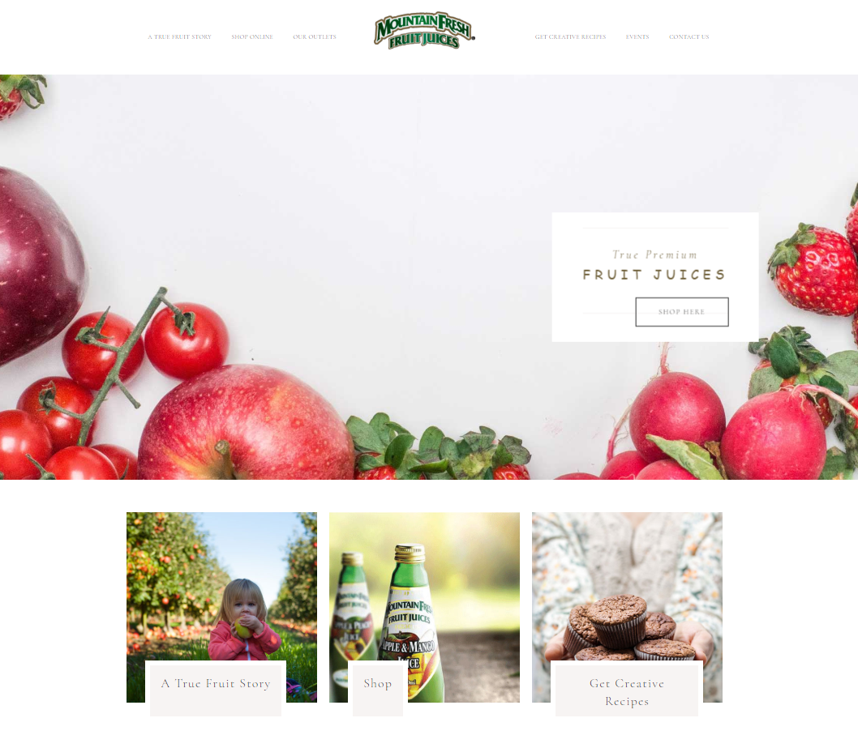

**Figure 2.1** – Screenshots of Mountain Fresh Fruit Juice Homepage

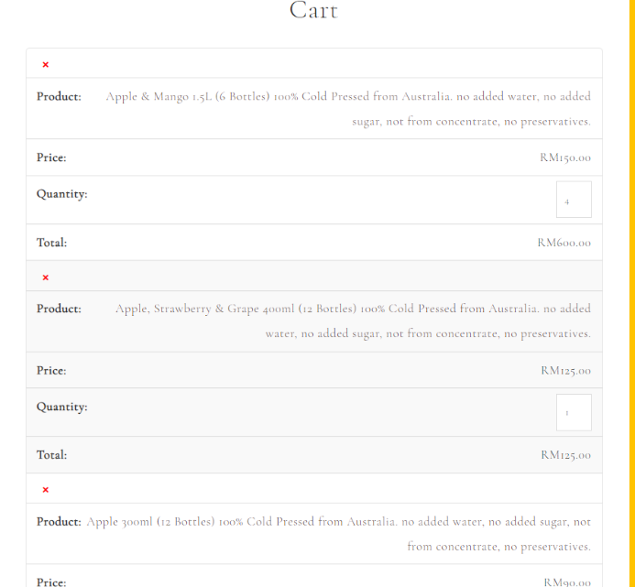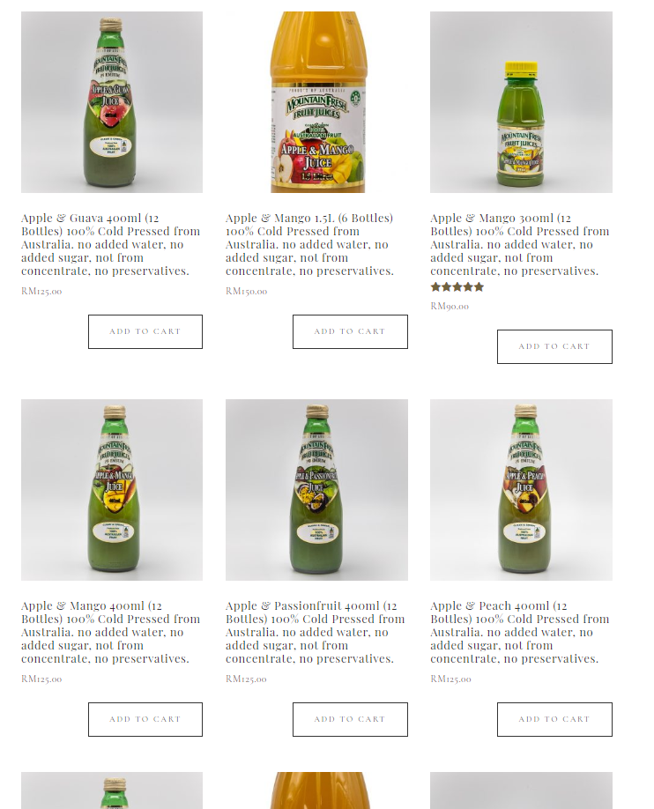

**Figure 2.3** – Screenshots of Mountain Fresh Fruit Juice Shopping Cart

**Figure 2.2** – Screenshots of Mountain Fresh Fruit Juice Main Product Page

Strength

1. Throughgoing description after adding to cart and before paying.
2. Easy user interface navigation
3. There’s a customer star review function.
4. A review comment field below every product and display it above it.
5. Able to show image of the products.

Weakness

1. Small and thin font, making it hard to see and read.
2. Google map is just showing nothing, showing just Southeast Asia instead of marking anything on the map.
3. Unable to show products with 3D view.

# **2.2 Universal NutriBeverage** (Universal NutriBeverage Malaysia, 2020)**.**

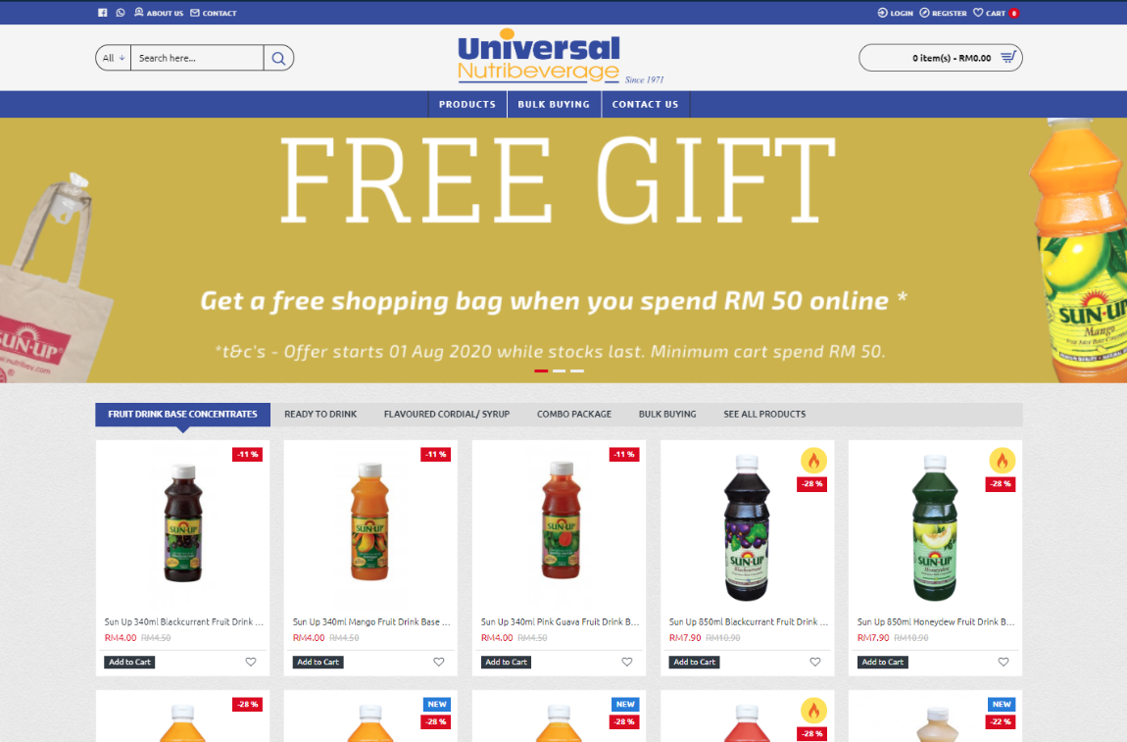Universal NutriBeverage was established since 1971 and over 45 years in beverage manufacturing. Their website is available for laptop, smartphones and other devices. Their website is focused on promoting their fruit drinks, and they also encourage consumers to online shopping on their website by giving out free shopping bag when the consumers spend RM50 online. They also have selections for customers to bulk buying when the customers need to buy a lot at once, and they also give out discounts for customers whom wish to bulk buying on their website.

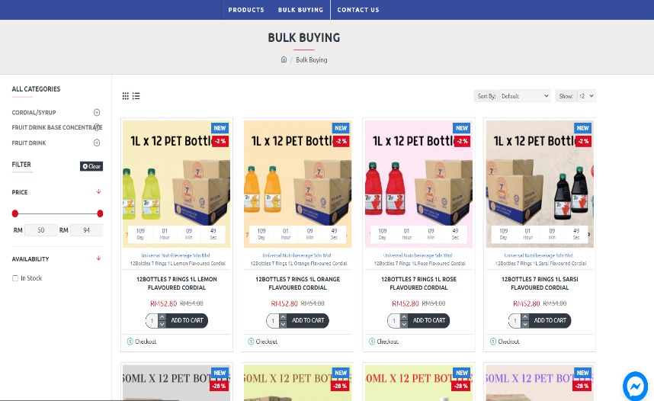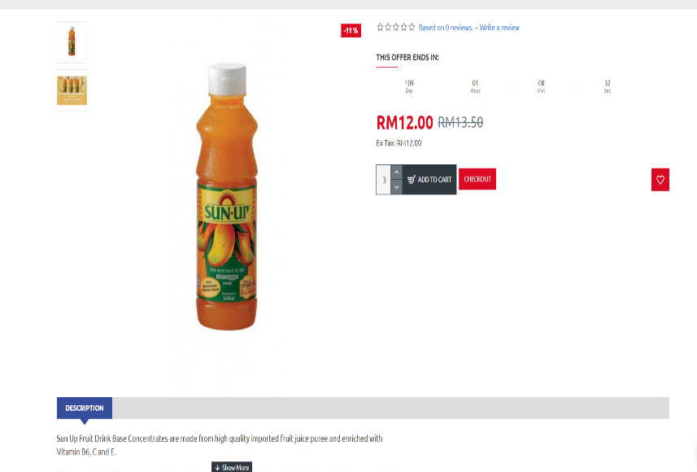

**Figure 2.4** – Screenshots of Universal NutriBeverage Main Product Page and Homepage

**Figure 2.5** – Screenshots of Mountain Fresh Fruit Juice Bulk Buying Page

**Figure 2.6** – Screenshots of Mountain Fresh Fruit Juice Product Page

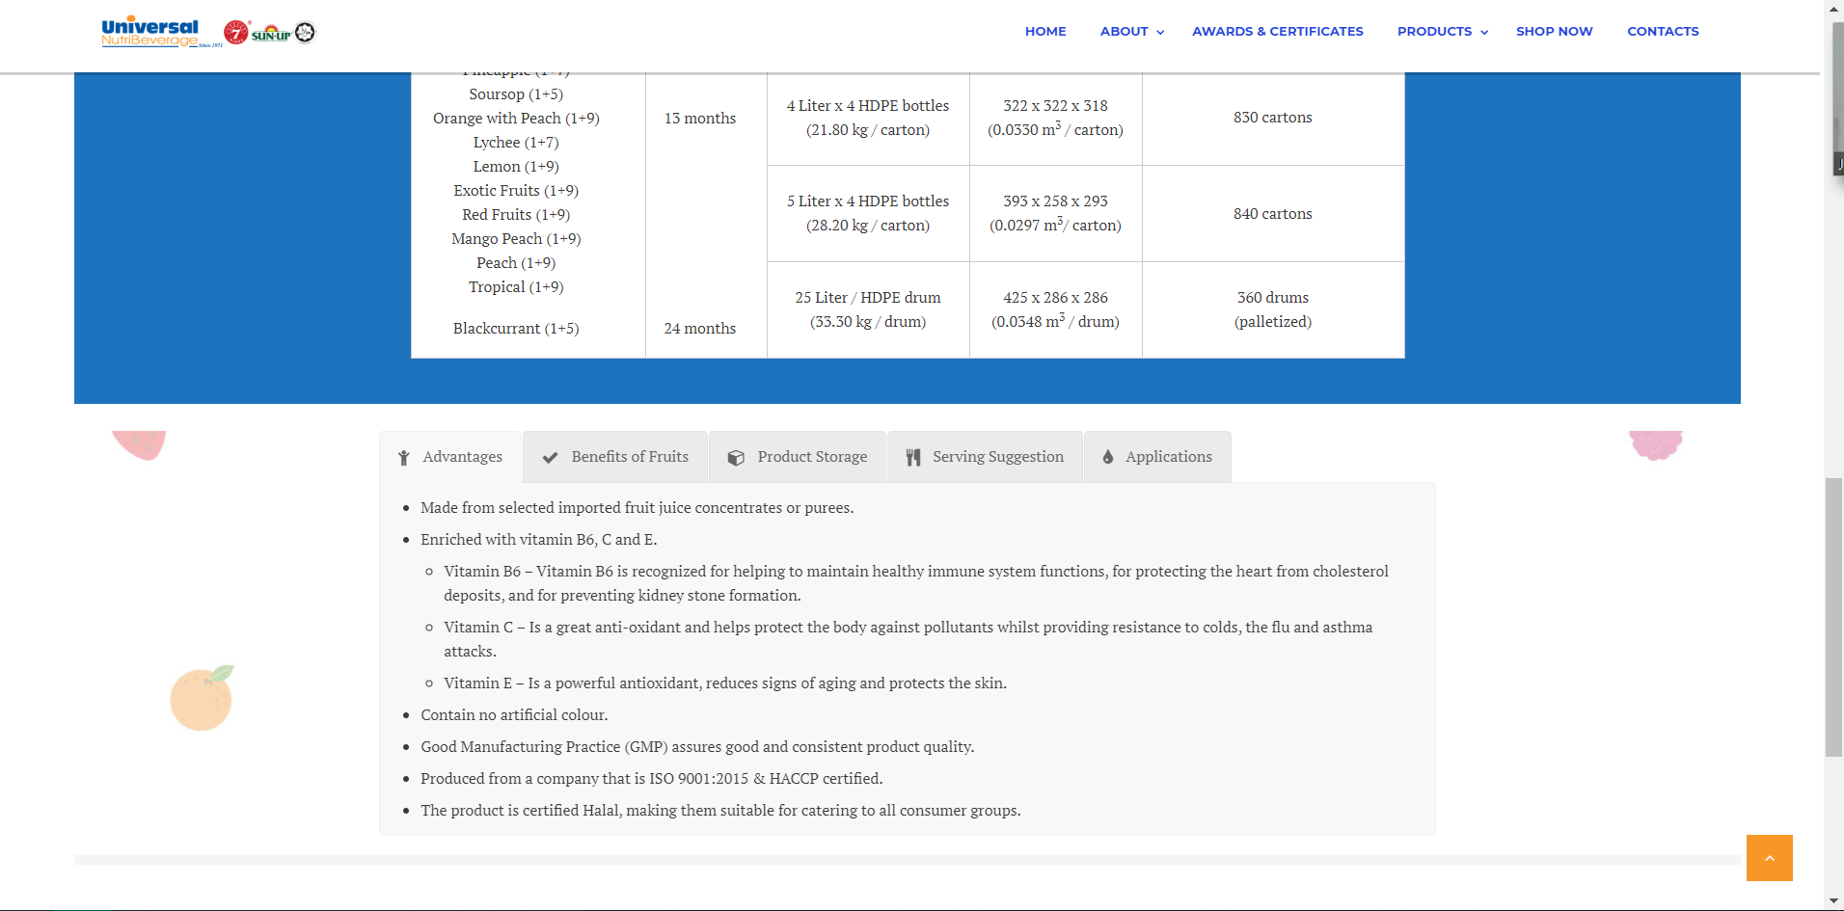

**Figure 2.7** – Screenshots of Mountain Fresh Fruit Juice About Page

Strengths

1. They provide a filter function for the customers and viewers to filter out the selections and requirements they want.
2. They also provide an attentive description for the products
3. After confirming the products in the shopping cart, users will be redirected to a checkout page, which the checkout page is very clear and easy to understand.
4. They provide an online chat function with the use of Facebook Messenger.
5. They provide a rating and review option for the users or buyers to refer.
6. Able to show image of the products.

Weakness

1. They did not provide any maps for the users to look at.
2. Unable to show products with 3D view.
3. No detailed description in every product page.

# **2.3 The Cool Juice** (The Cool Juice Malaysia, 2017)**.**

The Cool Juice is a cold pressed juice delivery company established in 2016 and they provide 100% fresh, raw and pure juice. The website does support laptop and smartphone browsing. The website is focused on explaining the benefits of their fruit juices. So, they do have a clear explanation of how their fruit juices can benefits the consumers. They do provide a series of programs for the consumers.

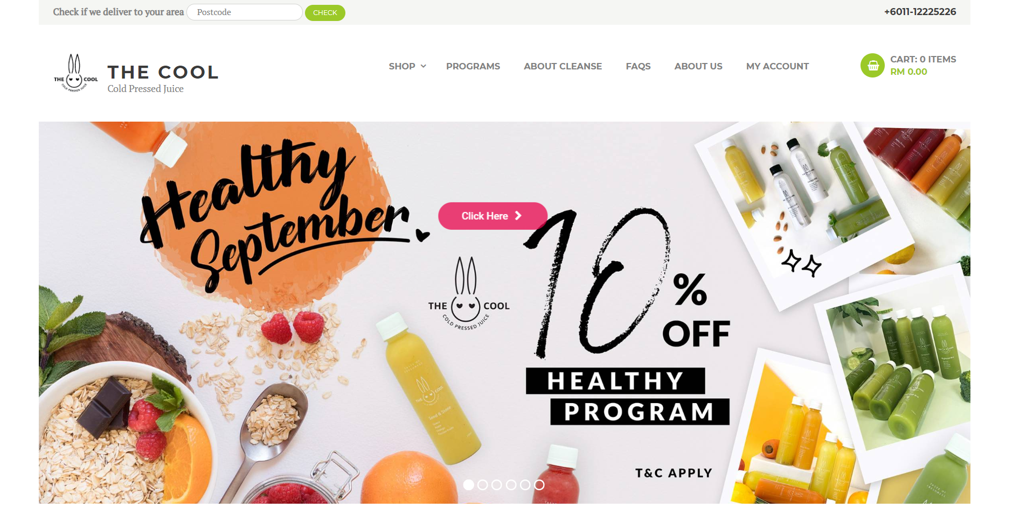

**Figure 2.8** – Screenshots of The Cool Juice Homepage

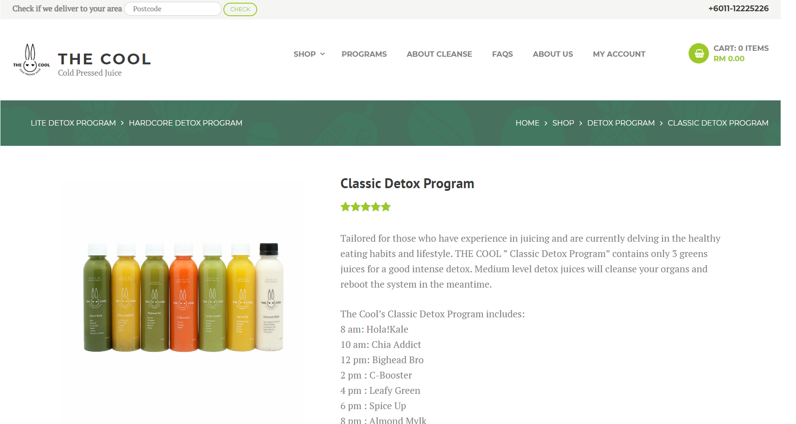

**Figure 2.9** – Screenshots of The Cool Juice Classic Detox Program Page

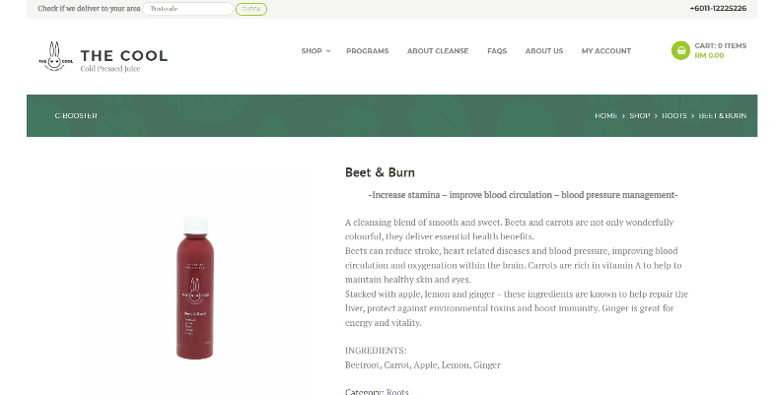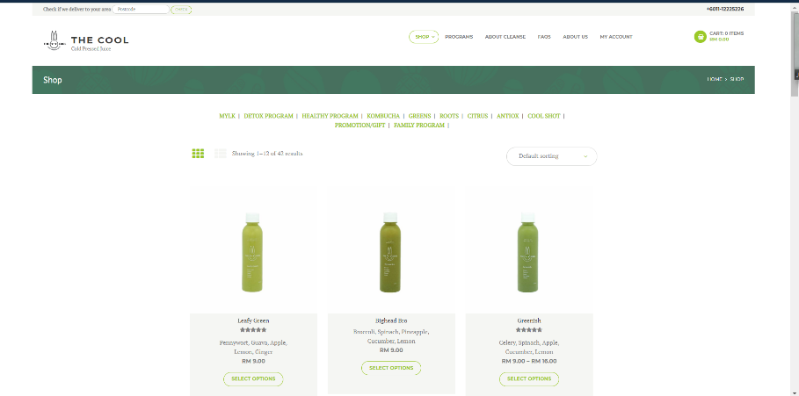

**Figure 2.10** – Screenshots of The Cool Juice Product Page

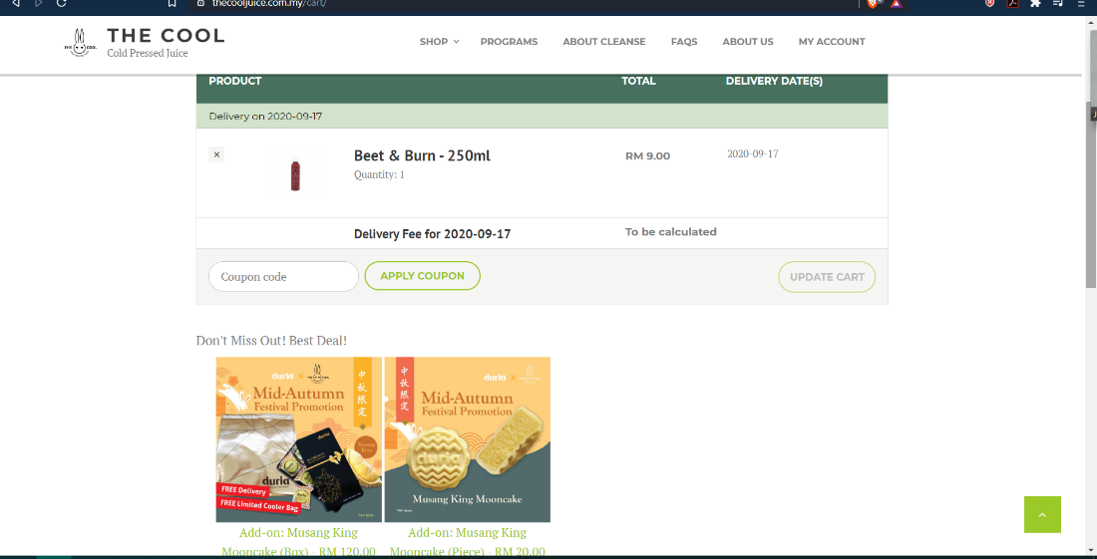

**Figure 2.11** – Screenshots of The Cool Juice Beet & Burn Juice Page

**Figure 2.12** – Screenshots of The Cool Juice Shopping Cart Page

Strengths

1. They provide a clear explanation and introduction on their products and programs for their customers.
2. They also provide a star rating function below every product.
3. The comment review function is also provided below every product too.
4. Able to show image of the products.

Weakness

1. Too much information and words in the website, it is hard to look for what to buy.
2. The menu of juices is too hard to navigate through, the programs take up too many contents in the website.
3. The add-ons in the shopping cart is never to be seen in the website, they did not advertise their add-ons properly.
4. They did not provide any maps for the viewers.
5. Unable to show products with 3D view.

|  |  |  |  |  |
| --- | --- | --- | --- | --- |
| **Features** | **Mountain Fresh Fruit Juice** | **Universal NutriBeverage** | **The Cool Juice** | **Fruit Havana** |
| Browsable devices | Universal | Universal | Universal | Universal |
| Google Maps | P | O | O | P |
| Rating on products | P | P | P | P |
| Comment Feedback | P | P | P | P |
| Filter on products | O | P | O | O |
| Ease of use | Easy | Easy | Difficult | Very Easy |
| In-shop Pickup | O | P | O | P |
| 3D view mode | O | O | O | O |
| Detailed explanation | Detailed | Not detailed | Very detailed | Detailed |
| Well-categorized products | P | P | O | P |

**Table 2.1** – Table of comparison between proposed website with other existing reviewed website

# **Chapter 3: Designs**

# **Wireframes**

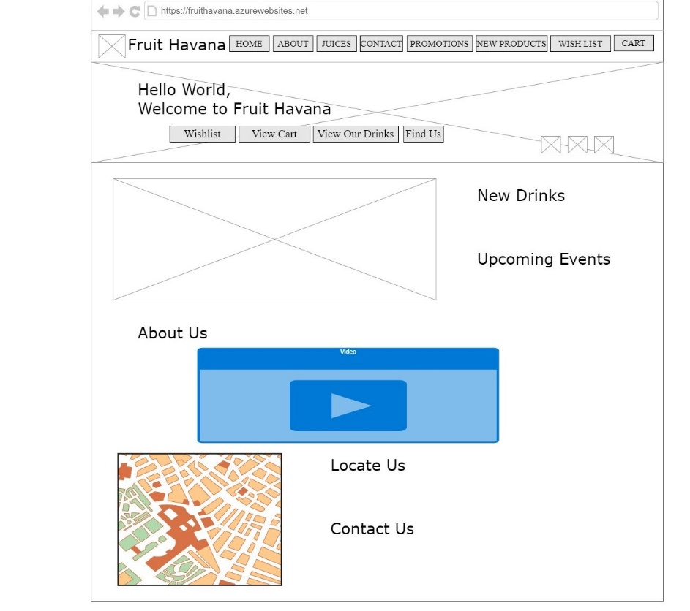

**Figure 3.1.1** – Wireframe of Main Product Page

**Figure 3.1.0** – Wireframe of Home Page

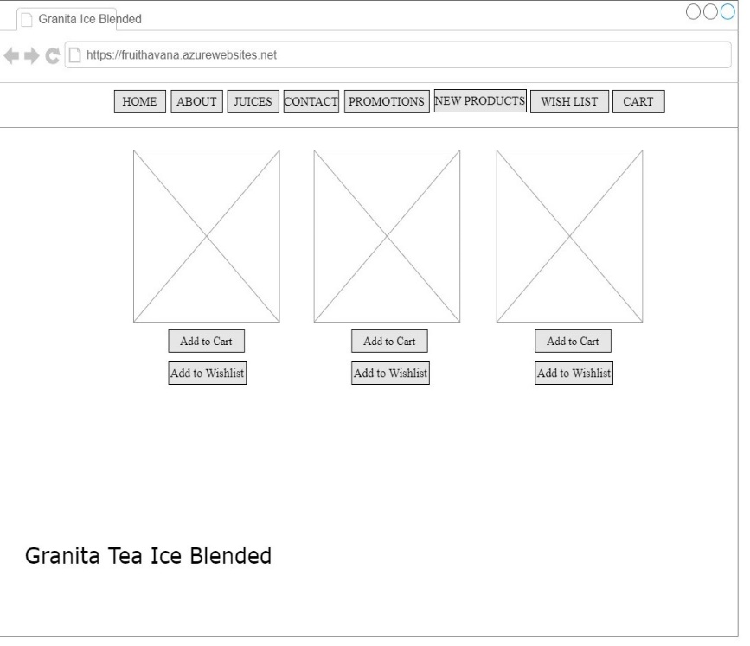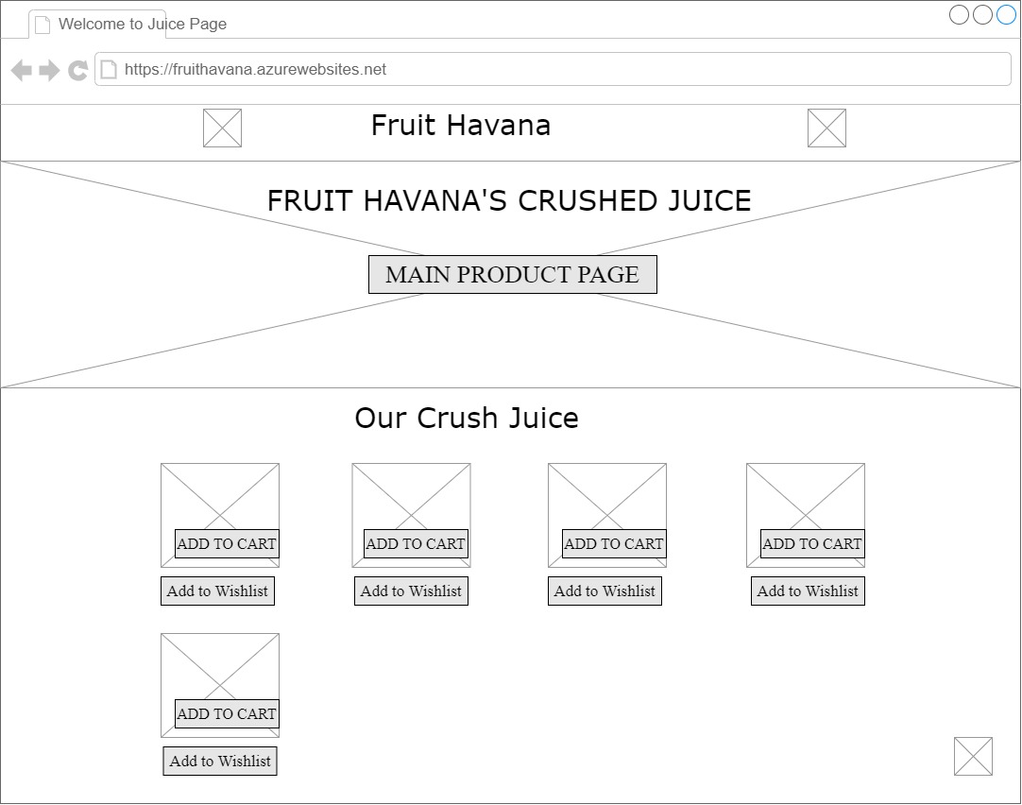

**Figure 3.1.2** – Wireframe of Crushed Juice Page

**Figure 3.1.3** – Wireframe of Granita Tea Ice Blended Page

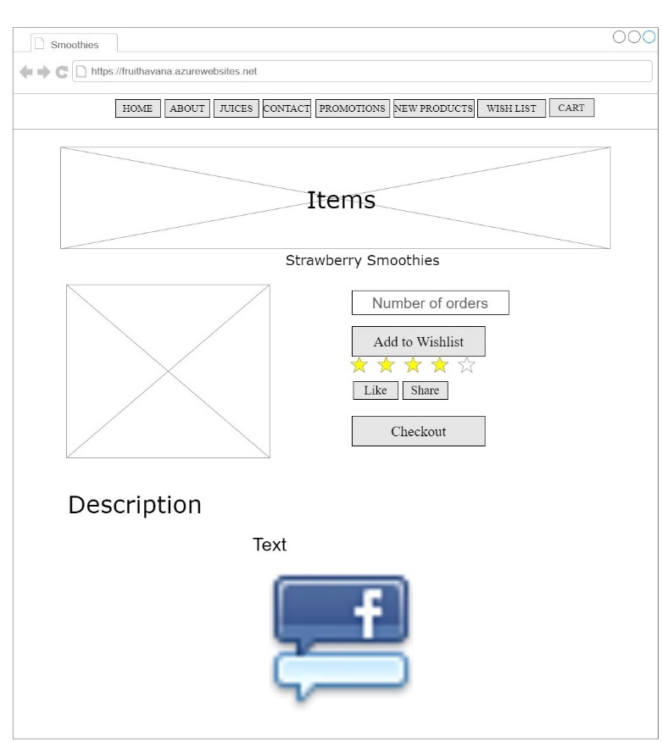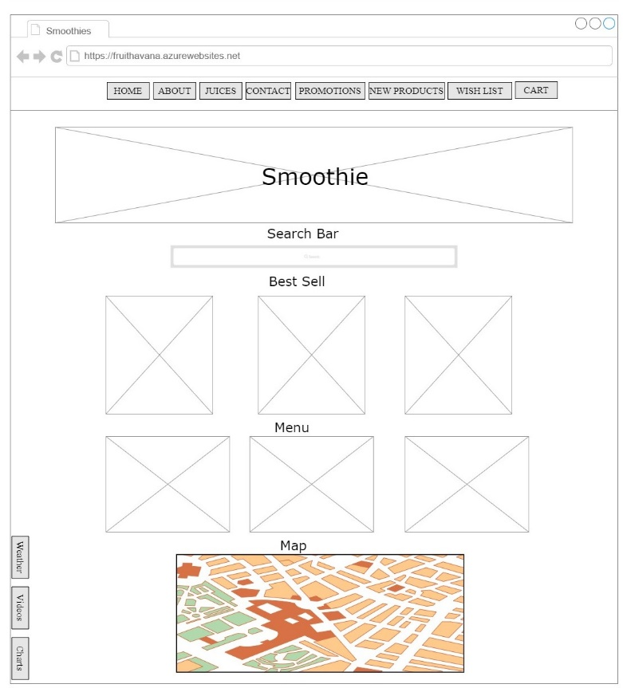

**Figure 3.1.4.1** – Wireframe of Smoothies 1 Page

**Figure 3.1.4.0** – Wireframe of Smoothies Page

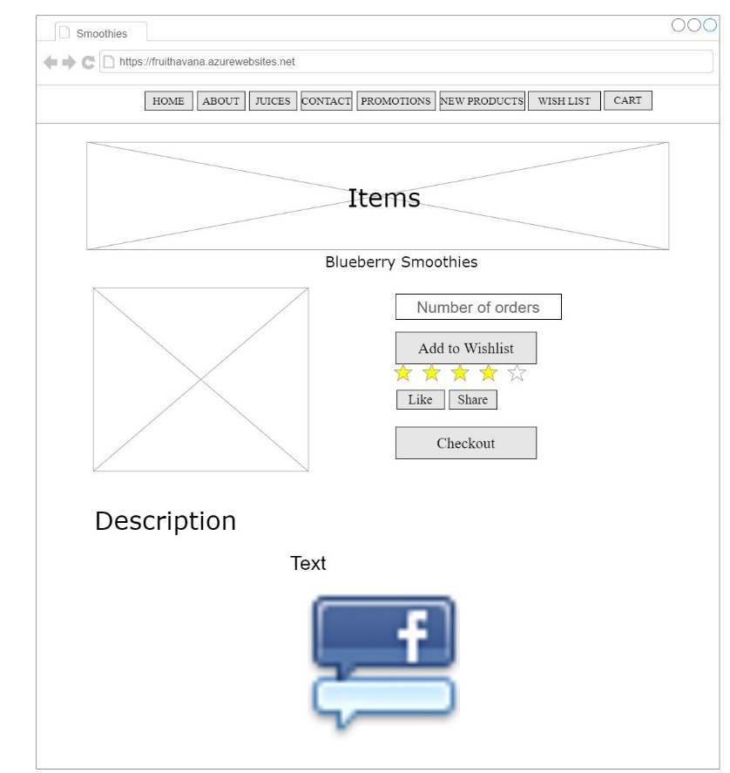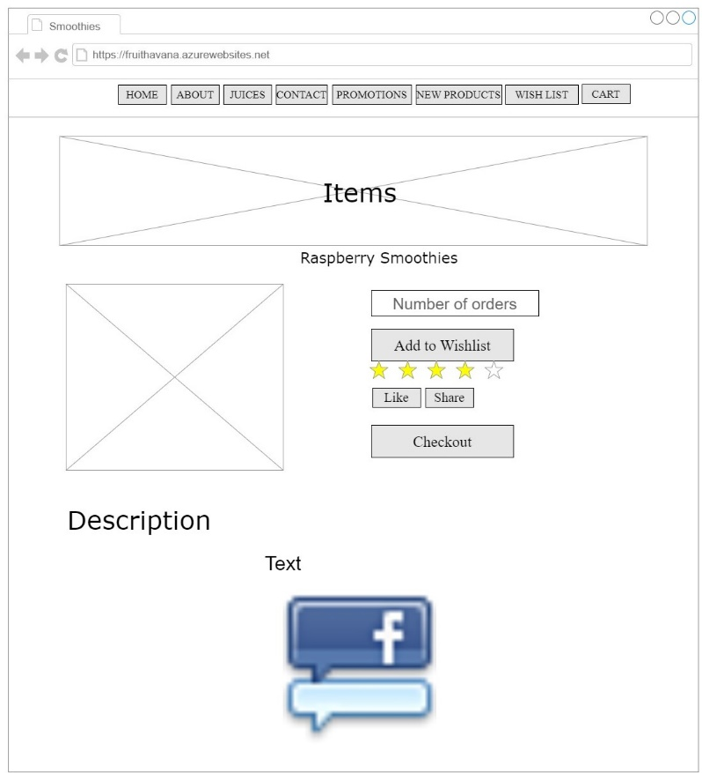

**Figure 3.1.4.3** – Wireframe of Smoothies 3 Page

**Figure 3.1.4.2** – Wireframe of Smoothies 2 Page

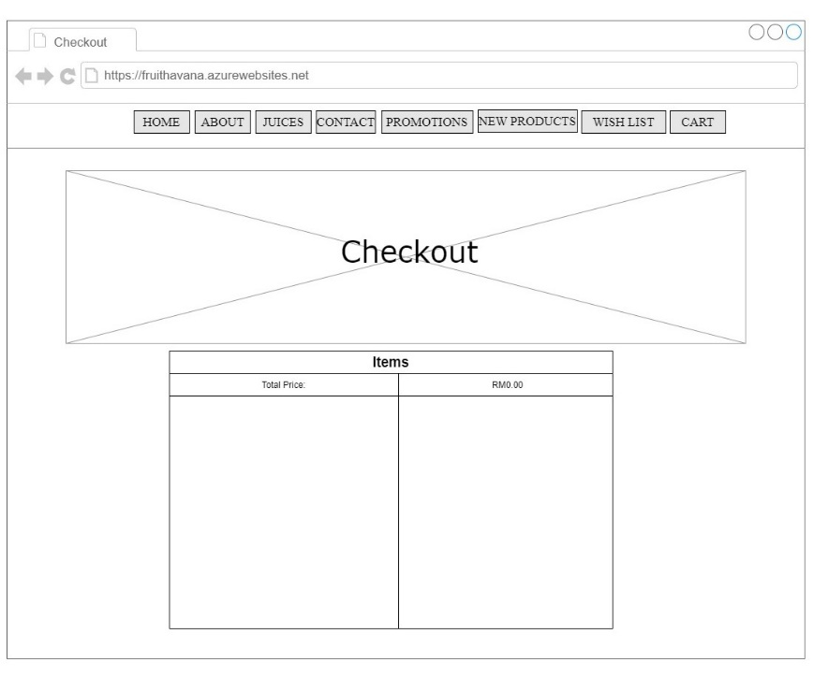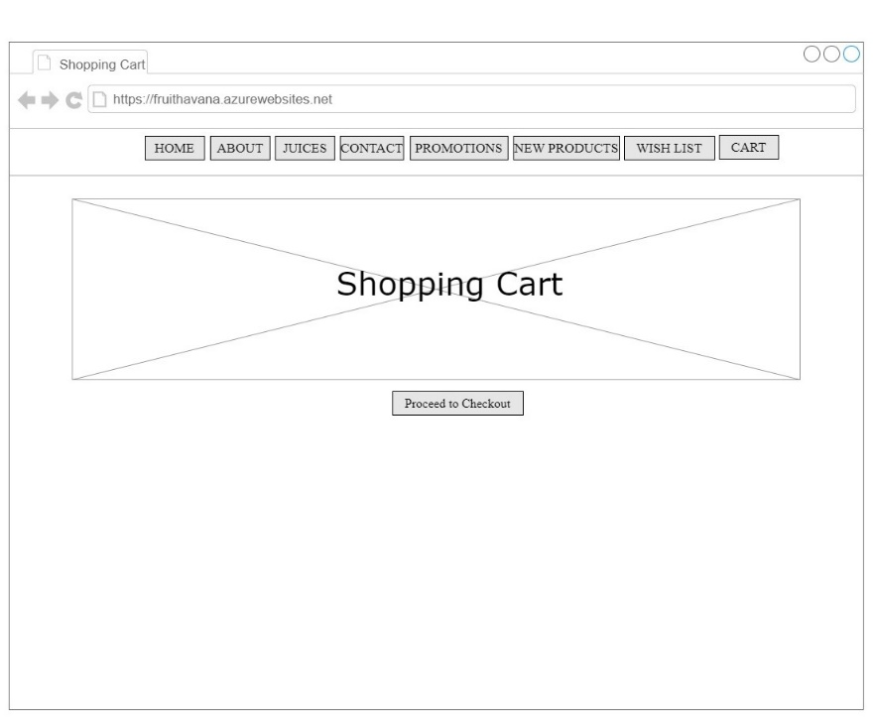

**Figure 3.1.6** – Wireframe of Checkout Page

**Figure 3.1.5** – Wireframe of Shopping Cart Page

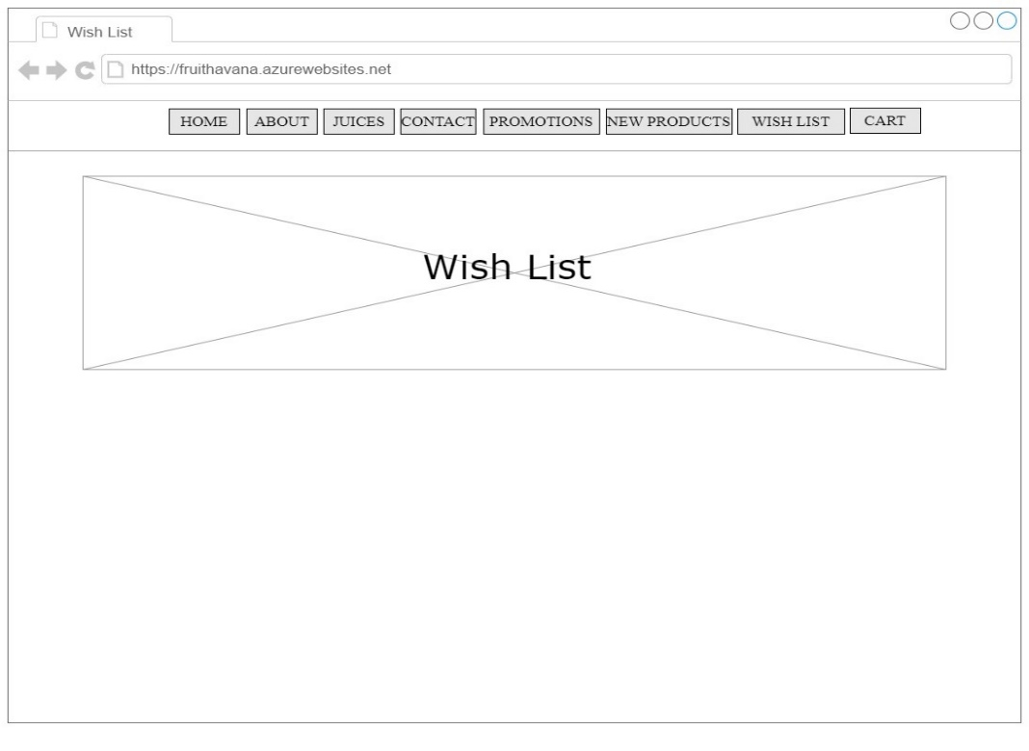

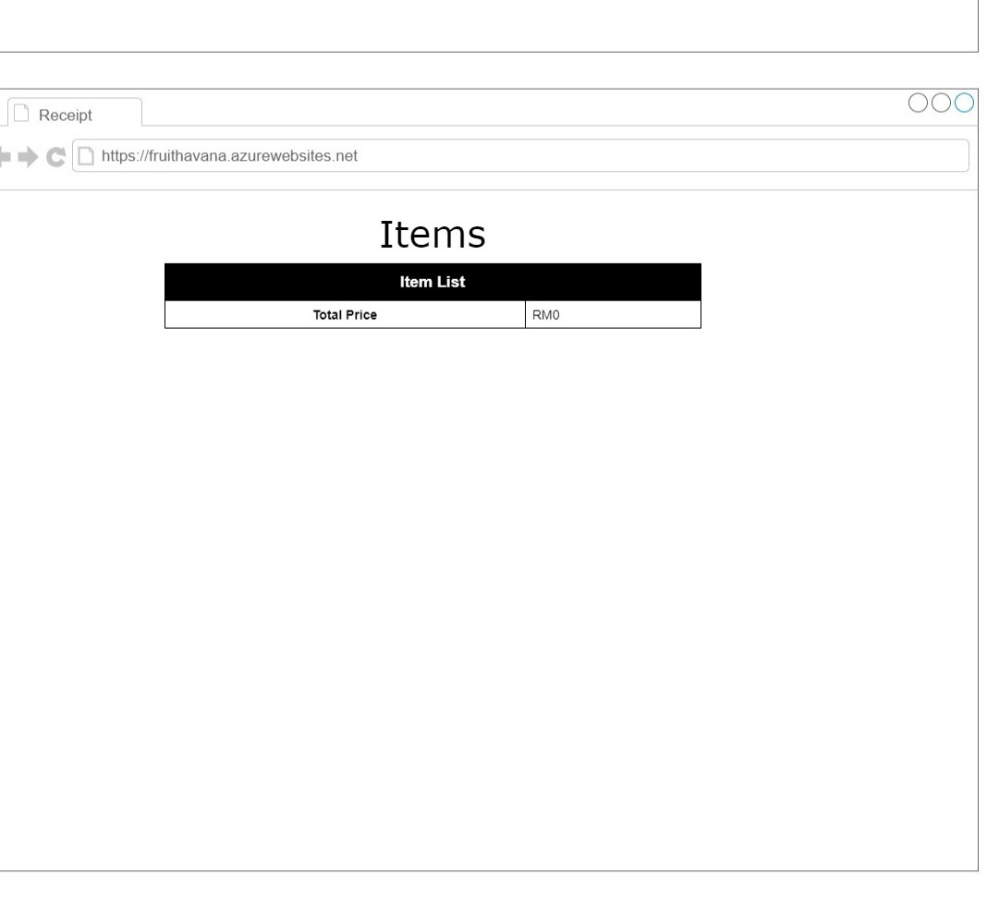

**Figure 3.1.7** – Wireframe of Wish List Page

**Figure 3.1.8** – Wireframe of Receipt Page

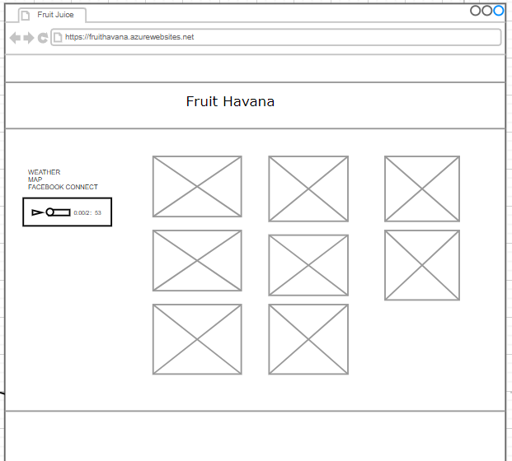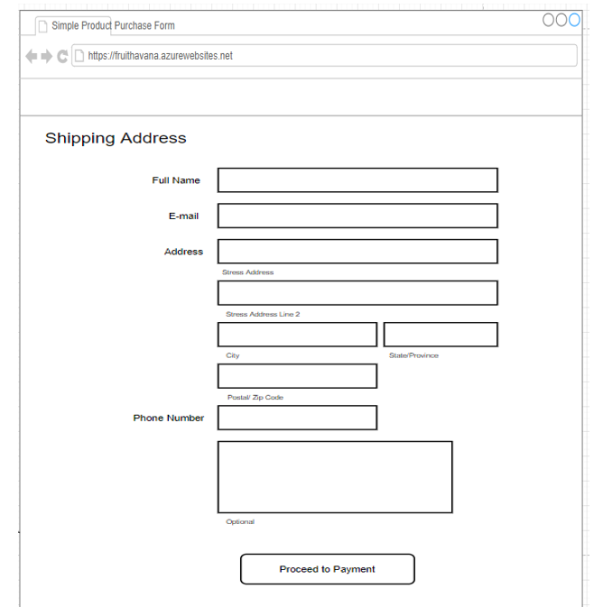

**Figure 3.2.0** – Wireframe of Fruit Juice Menu

**Figure 3.1.9** – Wireframe of Shipping Address

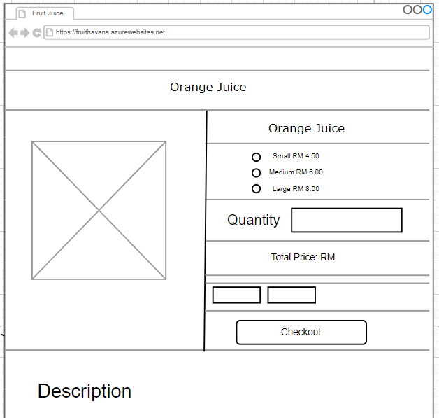

**Figure 3.2.1** – Wireframe of Fruit Juice Order

# **Page Mockup**

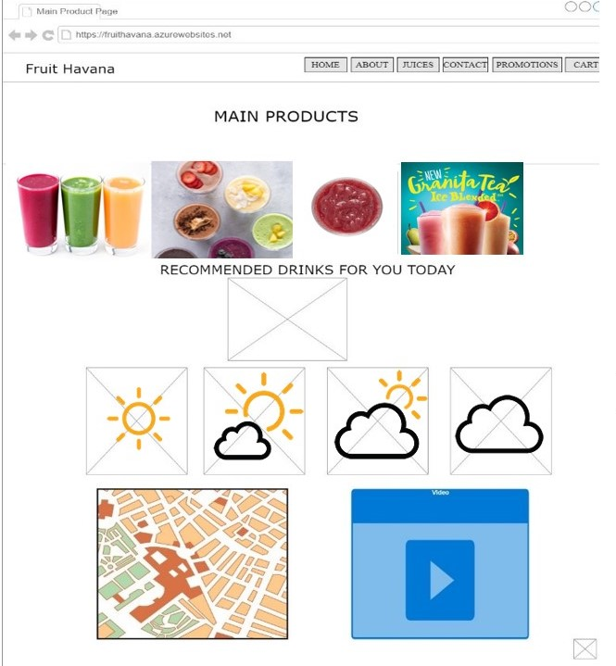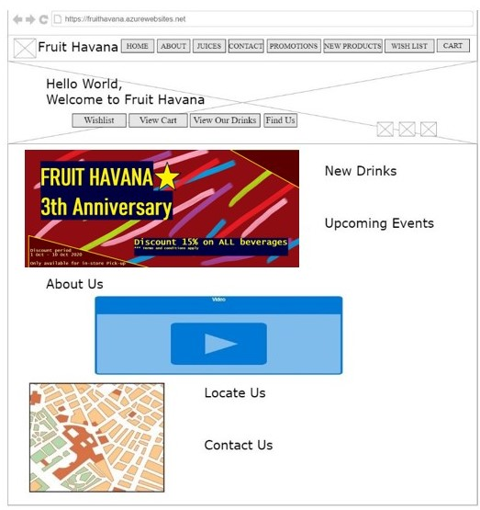

**Figure 3.2.0** – Page Mockup of Home Page

**Figure 3.2.1** – Page Mockup of Main Product Page

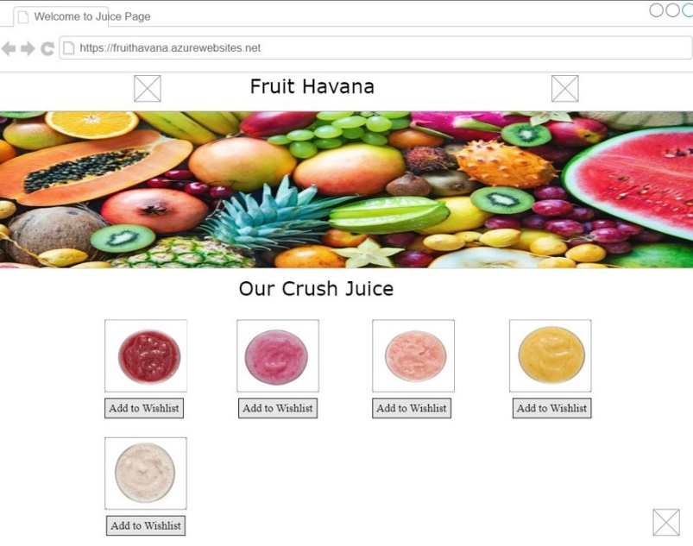

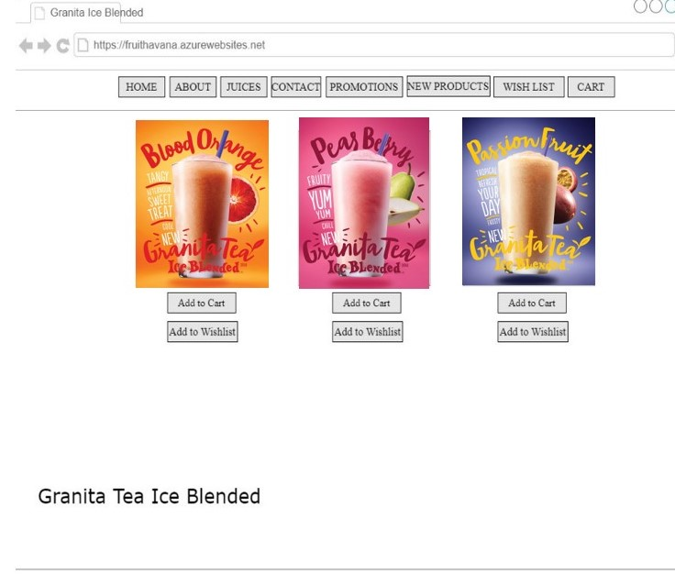

**Figure 3.2.3** – Page Mockup of Granita Tea Ice Blended Page

**Figure 3.2.2** – Page Mockup of Crushed Juice Page

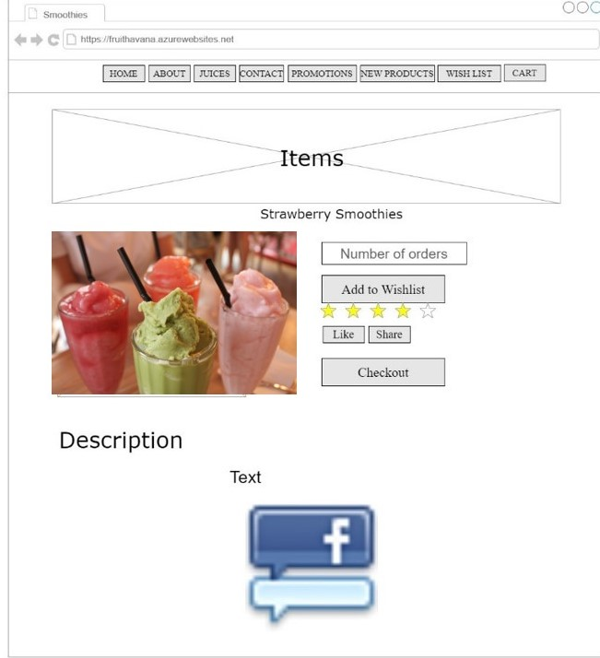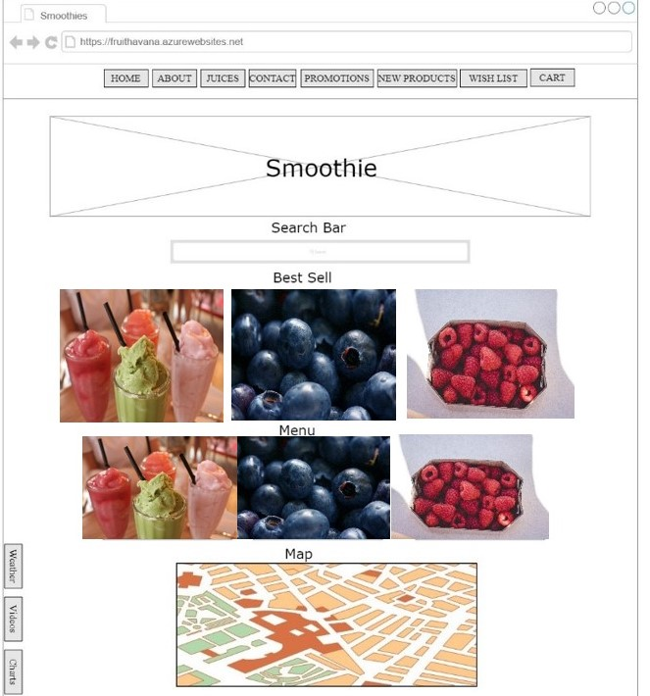

**Figure 3.2.4.1** – Page Mockup of Smoothies 1 Page

**Figure 3.2.4.0** – Page Mockup of Smoothies Page

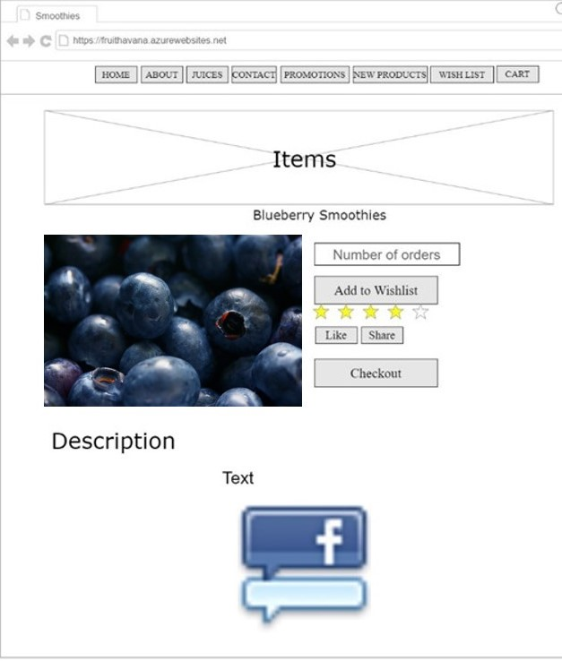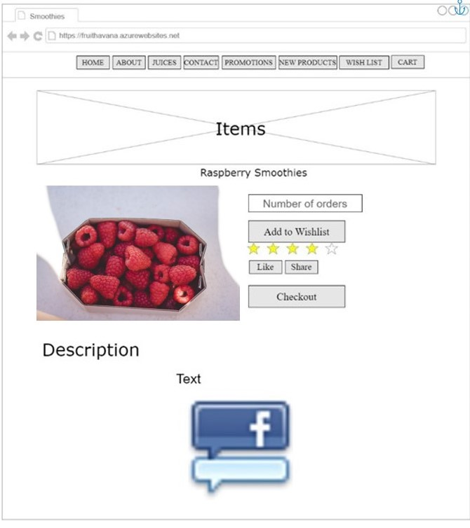

**Figure 3.2.4.2** – Page Mockup of Smoothies 2 Page

**Figure 3.2.4.3** – Page Mockup of Smoothies 3 Page

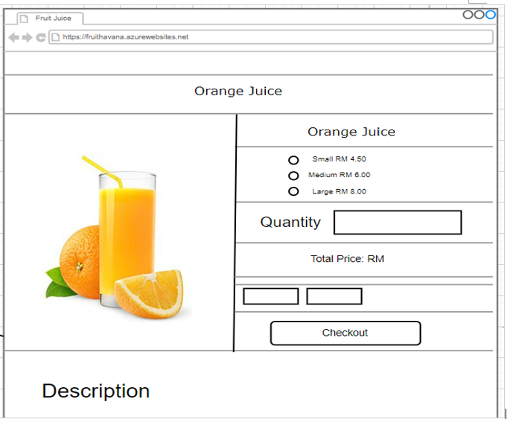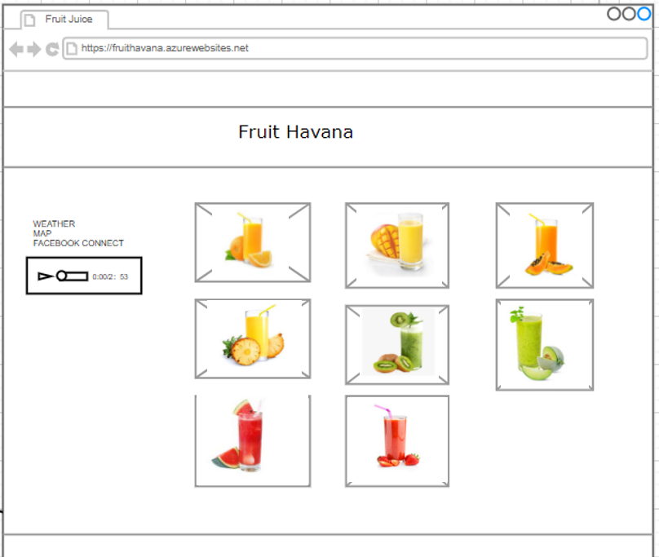

**Figure 3.2.5.1** – Page Mockup of Fruit Juice Order

**Figure 3.2.5.0** – Page Mockup of Fruit Juice Menu

# **Site Map**

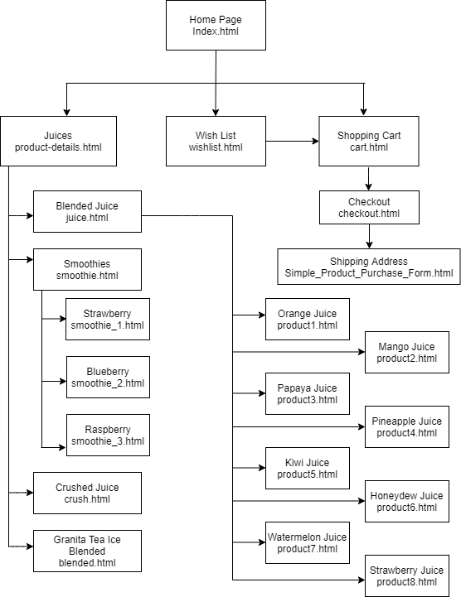

# **Chapter 4- Evaluation**

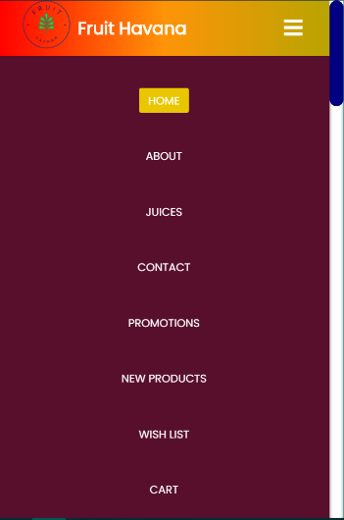

When the user enters the Homepage of our website, they will see this vibrant coloured homepage which gives the users and viewers options to navigate through the website with clear and easy buttons which makes the user’s browsing experience easy and elegant. They could navigate through the website with the buttons in the navigation bar which is on top of the homepage. And they could easily navigate to any corner of the website through these navigation bar in every webpage. Fruit Havana is going to have their own Facebook, Instagram and Twitter account, which it will be available for the users soon after clicking these social media buttons, the users will be redirected to Fruit Havana’s own social media webpages.

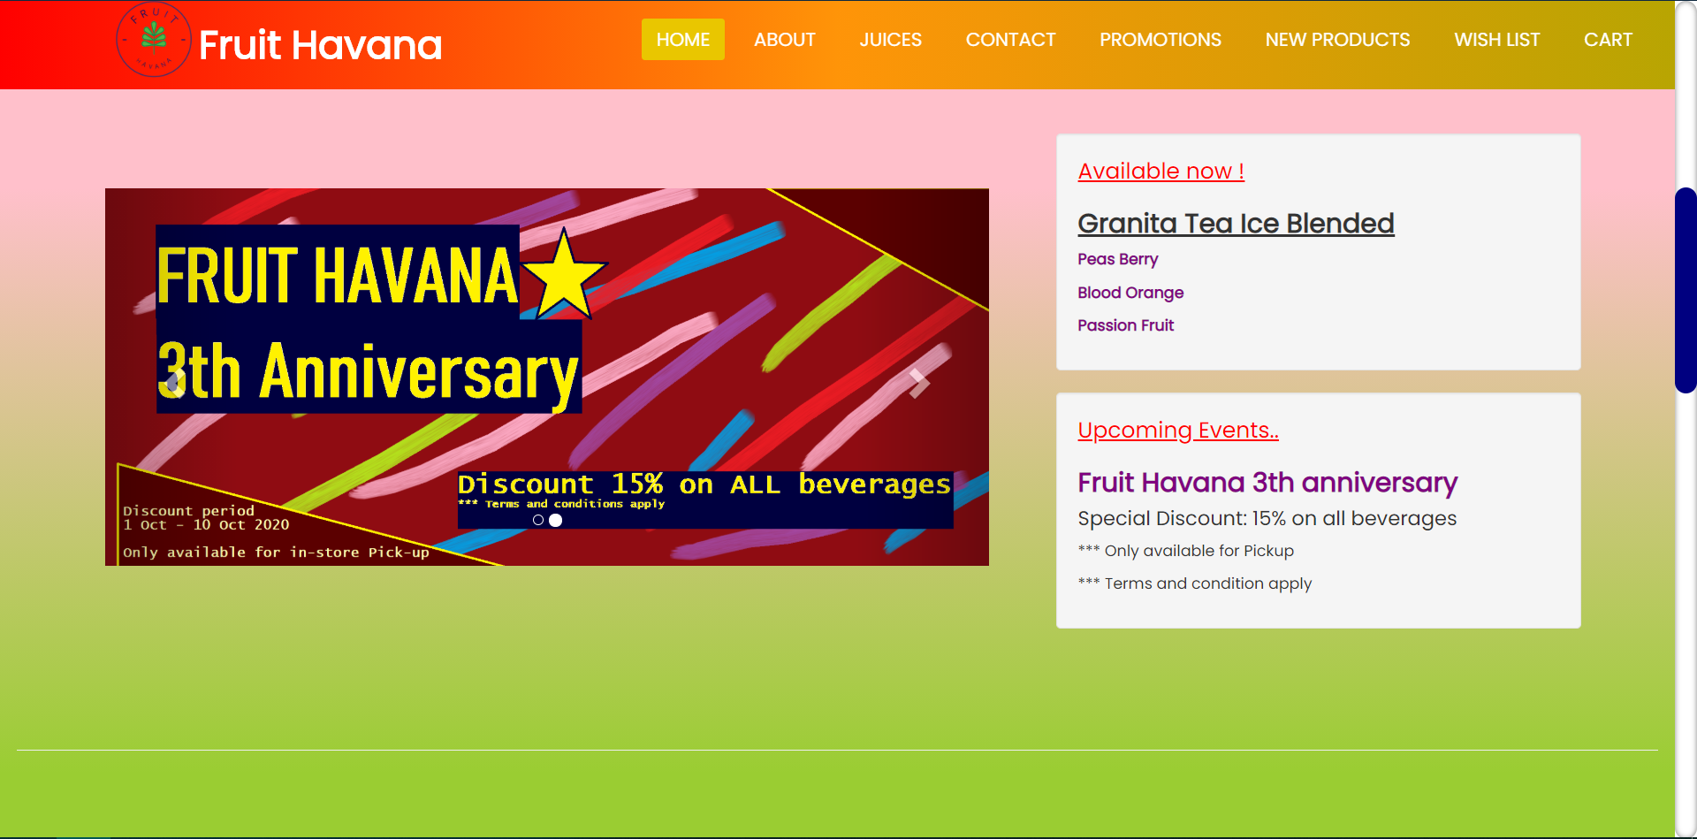

Users will be seeing this carousel image slider which it will keep on cycling the images of announcements, this kind of image showing will surely attract the viewer’s attention and they notice the announcements that Fruit Havana made.

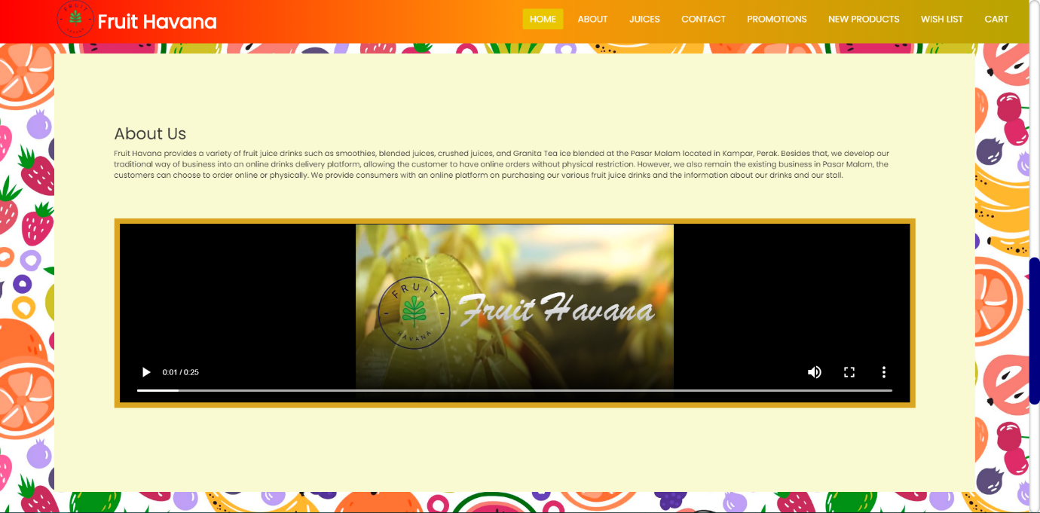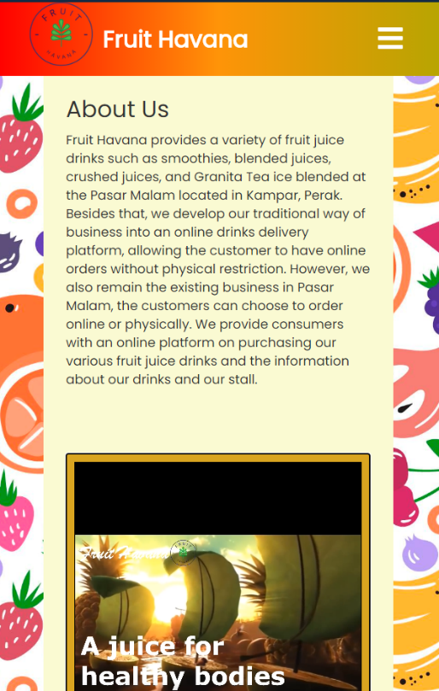

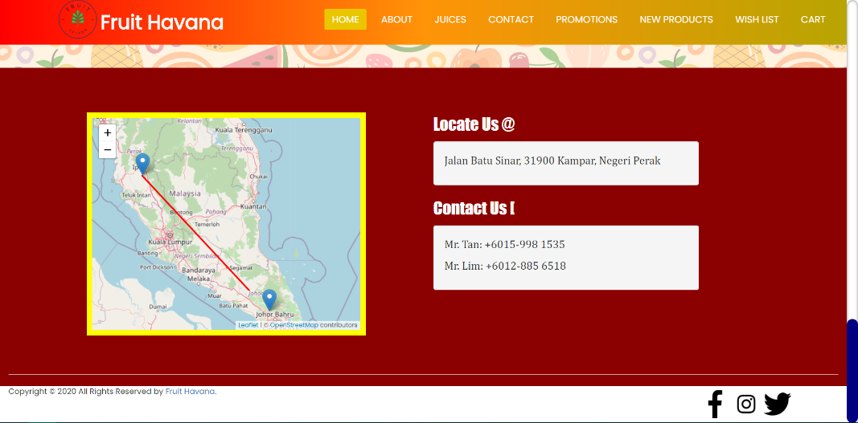In the About Us section, we placed a video under to let our users and viewers know more about us and to attract the user’s attention while watching the commercial that Fruit Havana made. We tried to deliver an expression to the viewers that our juices are fresh and healthy.

The last part of the homepage is the Locate Us and Contact Us, we provide our address and contact information to the users if they need to contact Fruit Havana, and we implement leaflet API to show the map in the Homepage of this website, it can get the current location of the users by popping up an alert message to ask for the user’s permission to get the user’s current location longitude and latitude, and it will also form a line between the current location of the users and the location of Fruit Havana. The footer of this page also shows the social media buttons of Fruit Havana.

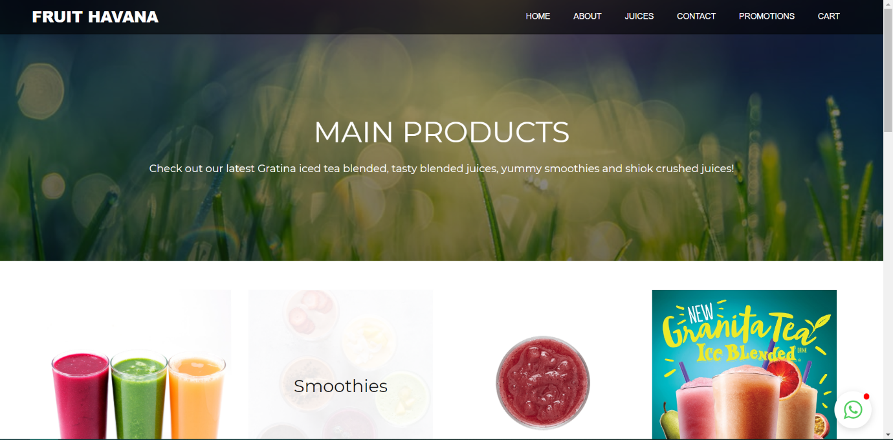

This page is the main product page of the Fruit Havana website, it will show four categories of the fruit juices, such as blended juices, smoothies, crushed juices, and lastly the new Granita Tea Ice Blended. Users could also navigate through webpages on the navigation bar above, users could simply click on the types of drinks they wanted and they will be redirected to the specific drinks that they chose. There is also a small embedded Whatsapp chat widget on the bottom-right of the screen. User’s could just simply click on it, and it will let the users log in to their respective Whatsapp accounts and they could contact Fruit Havana through Whatsapp.

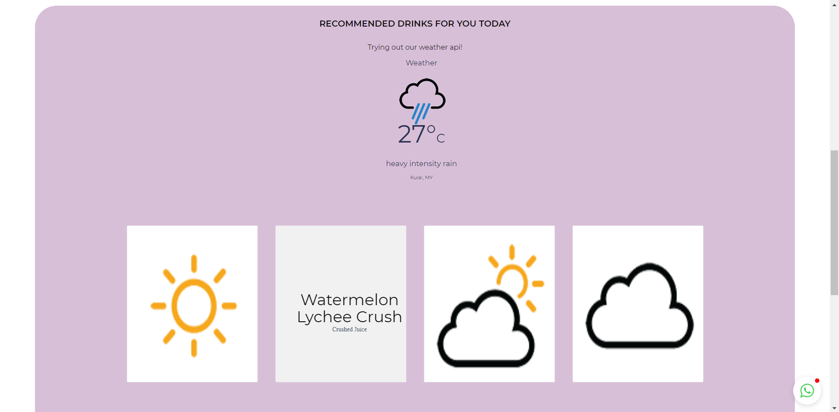

Below the main product page, there’s a section where it will recommend drinks for the users according to the current locations of the users. For example, if it is a sunny day, it will recommend Blood Orange Granita Tea ice blended for the consumers by flipping the sunny flip card. This innovative idea could attract the viewers and consumers attention. It will also prompt an alert from the users and get permission from them to get the current location of the users in order to get their current weather of the location they are at.

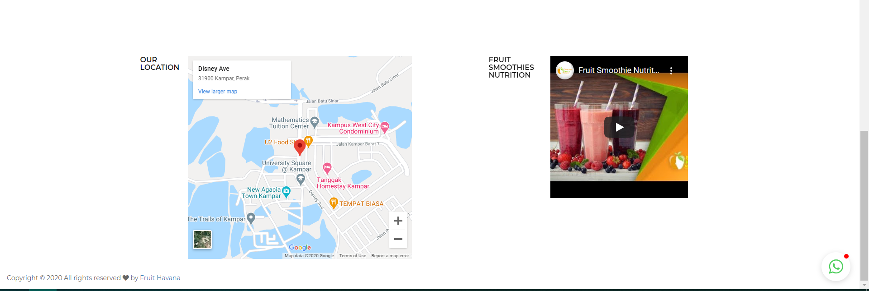

The last part of the main product page is the location of Fruit Havana and the embedded Youtube video of the nutrition of fruit smoothies. Which it will tell the benefits of drinking fruit smoothies by Fruit Havana.

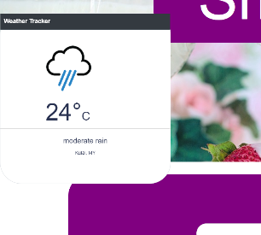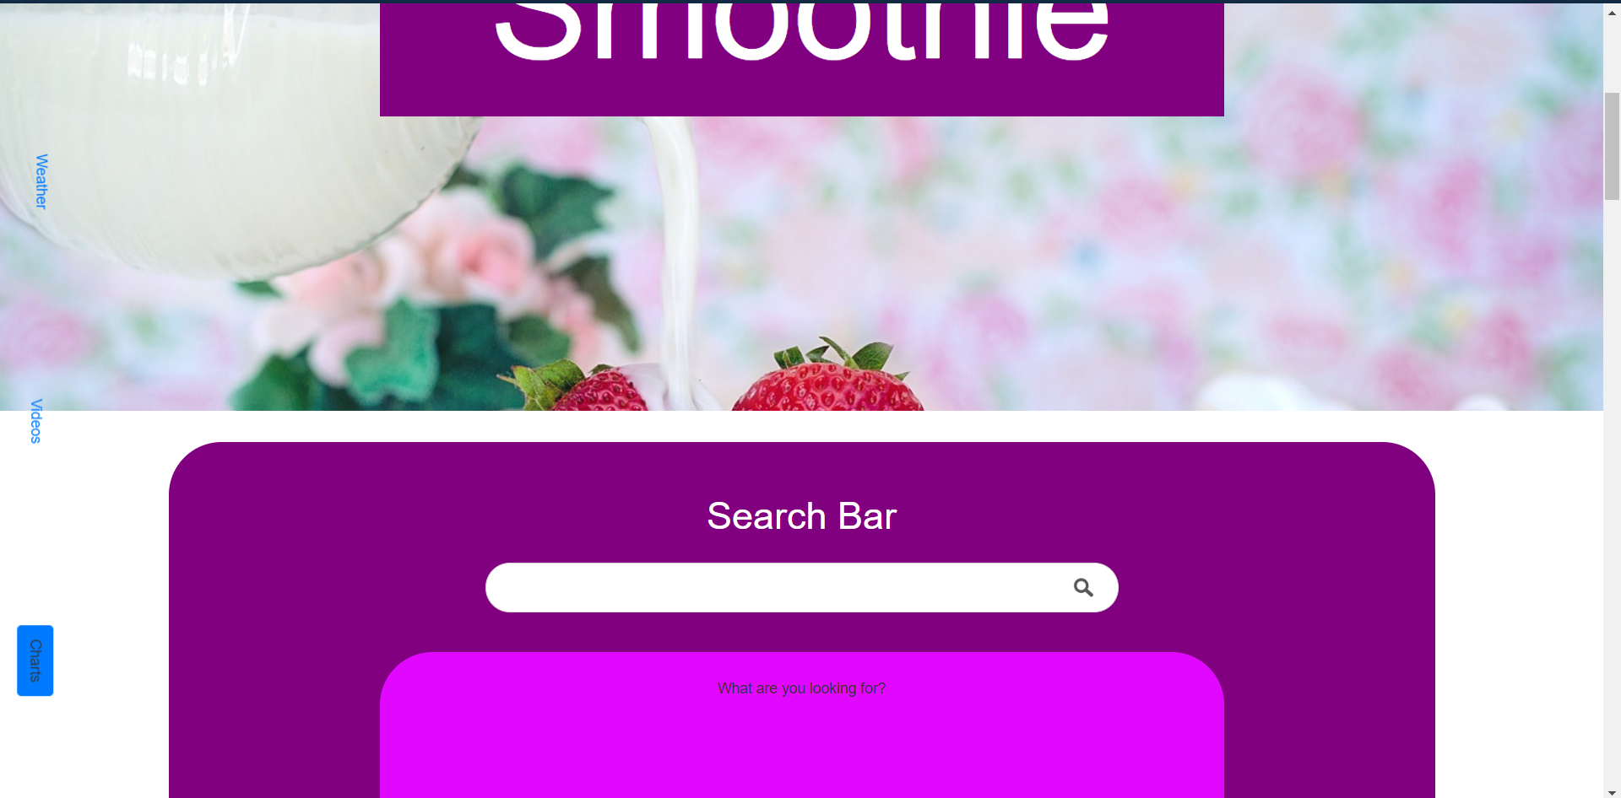

On the left hand side, there’s another navigation bar which it will pop up when the users clicked on it. For example, if the weather bar was clicked, it will display a weather bar by sliding out from the side.

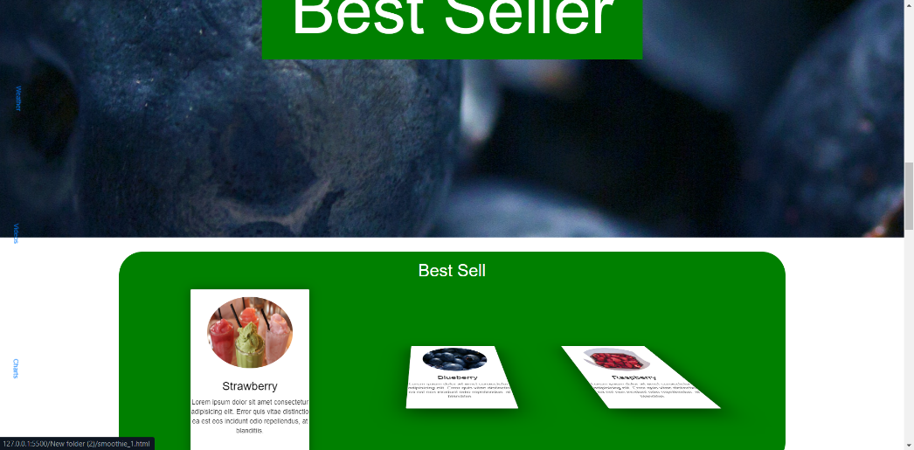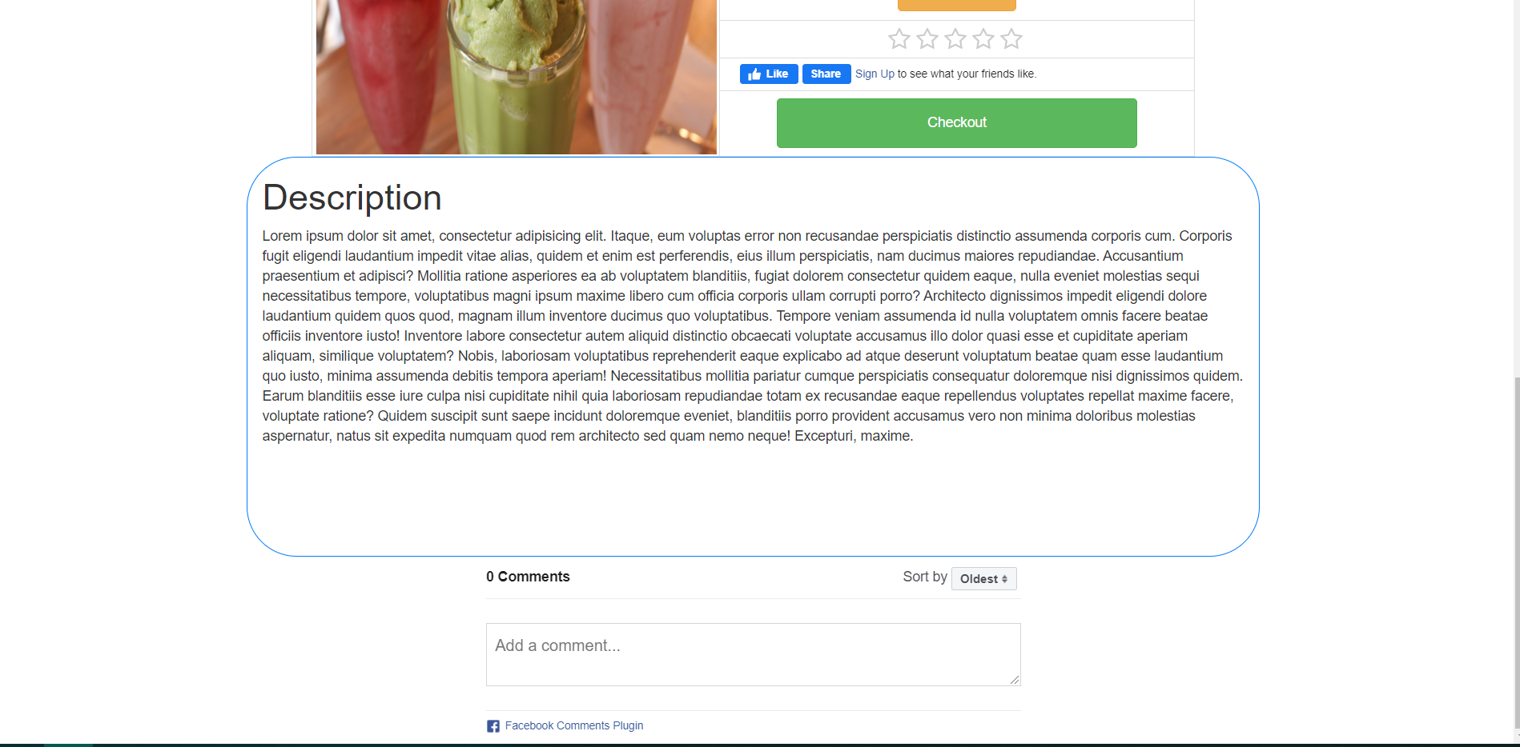

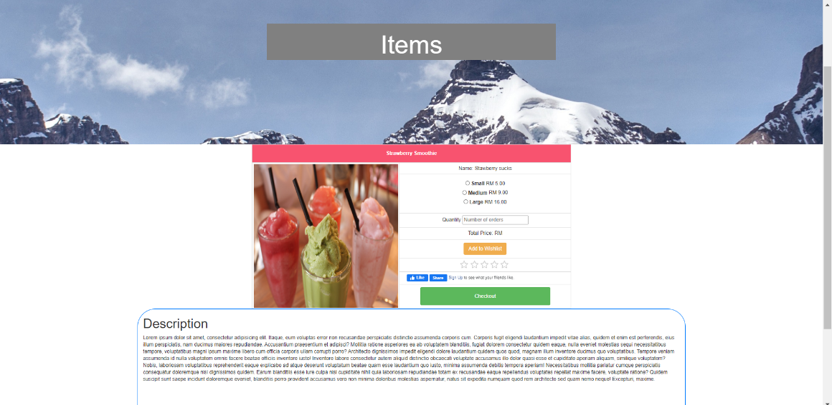

In the smoothies page, there’s a Best Seller section, which it will show the best seller items by making one of three cards stand when the user hovers on it, after the users click on it, they will be redirected to a page which it is the **individual product page**, detailed descriptions will be showed in the description section, also you can also rate the drinks individually by rating with stars. Besides that, users can also like and share the drinks on Facebook by logging in their Facebook pages. Consumers could also comment their reviews below the products, which it will also display below it. If users hover on top of the image of the smoothies, it will also show the materials that they have used in the drinks. Users could add the drinks into the wishlist, we implement local storage for the wishlist and shopping cart, because users could preserve their items in the shopping cart or the wishlist when they visit the website next time without even having accounts in the website. Buyers could just simply set the quantities of the items and just proceed to checkout, the items will be stored in the local storage and it will appear in the shopping cart.

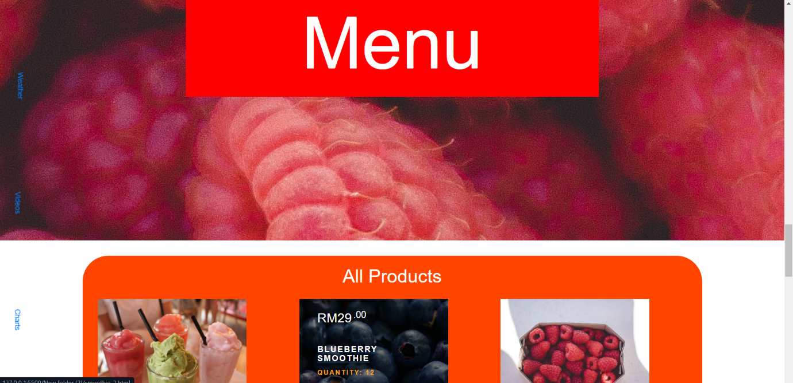

In the smoothies page, you could see the smoothies menu section, and there’s three items in the product page for the smoothies section, which is Blueberry smoothies, Raspberry smoothies and Strawberry smoothies. After clicking on the title of the products in the menu section, users will also be redirected to the individual product page respectively.

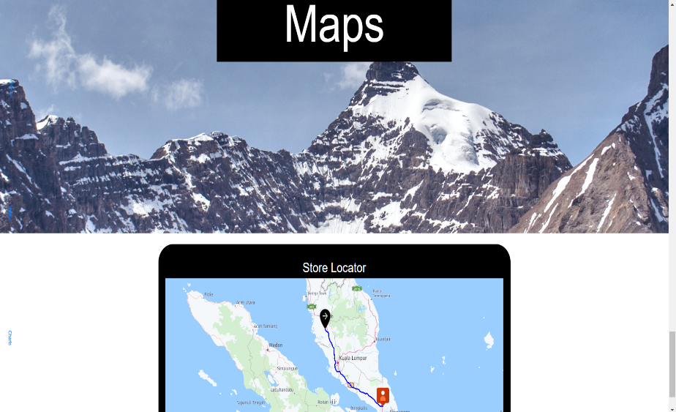We implement **Here Map** in the

Smoothies last section, which this

Store locator API could get the current

location of the users by alerting them

to get permissions to get their current

location, and it could also calculate the

**distance** between two markers.

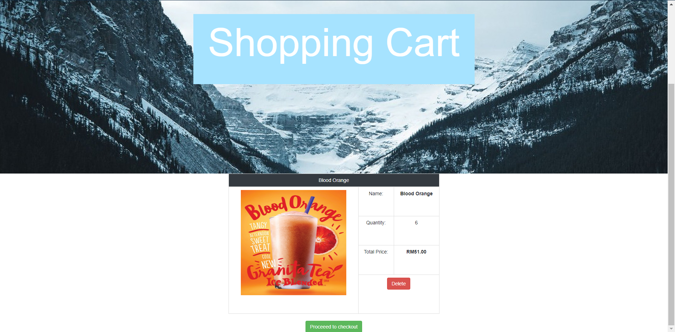

This part of our website is the shopping cart, which stores the drinks that the users wishes to buy online by retrieving , after clicking delete, it will delete the drinks from the shopping cart. After clicking proceed to checkout, the page will be redirected to the checkout page.

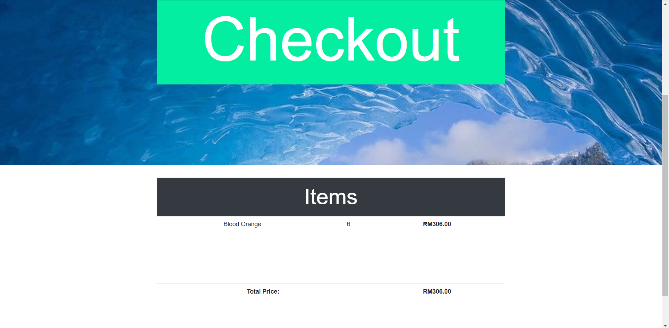

This is the checkout page of Fruit Havana, it will record the items that the users wishes to buy and confirm with the customers that the items are correct and ready to proceed to the transactions.

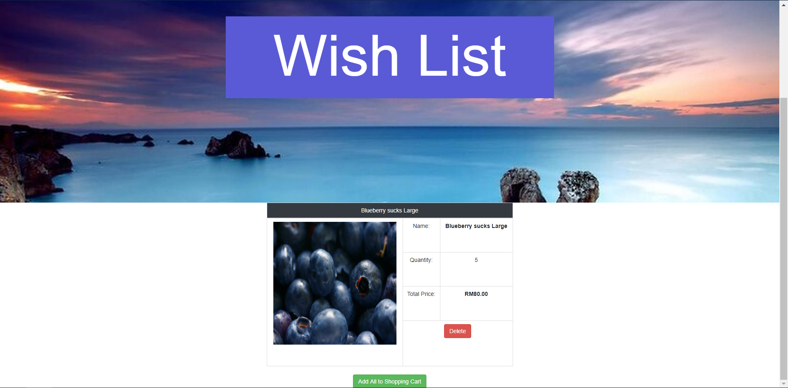

Moreover, this is the wishlist of the Fruit Havana’s website, after the users click on add to wishlist, it will appear inside here and it is stored by implementing local storage cookies. Users can just add all of the items to the shopping cart by clicking the button below. If the users do not wish to add the items in the wishlist, they could just simply delete the items by clicking the delete button.

**Notifications**

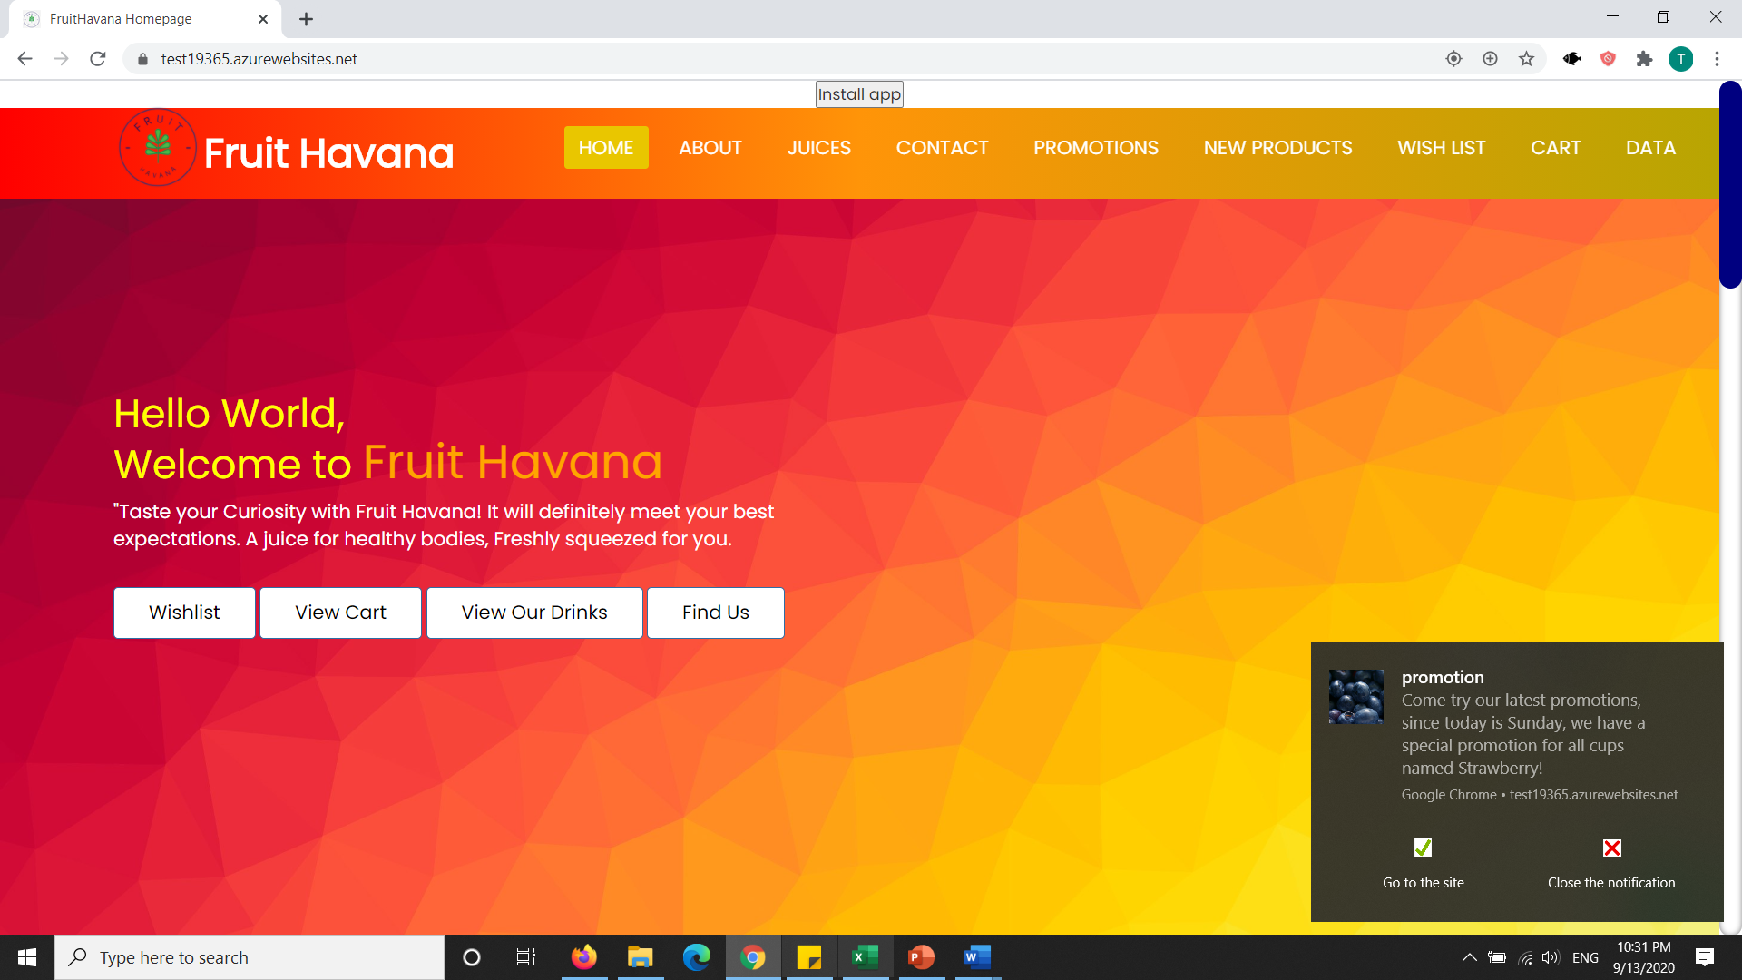

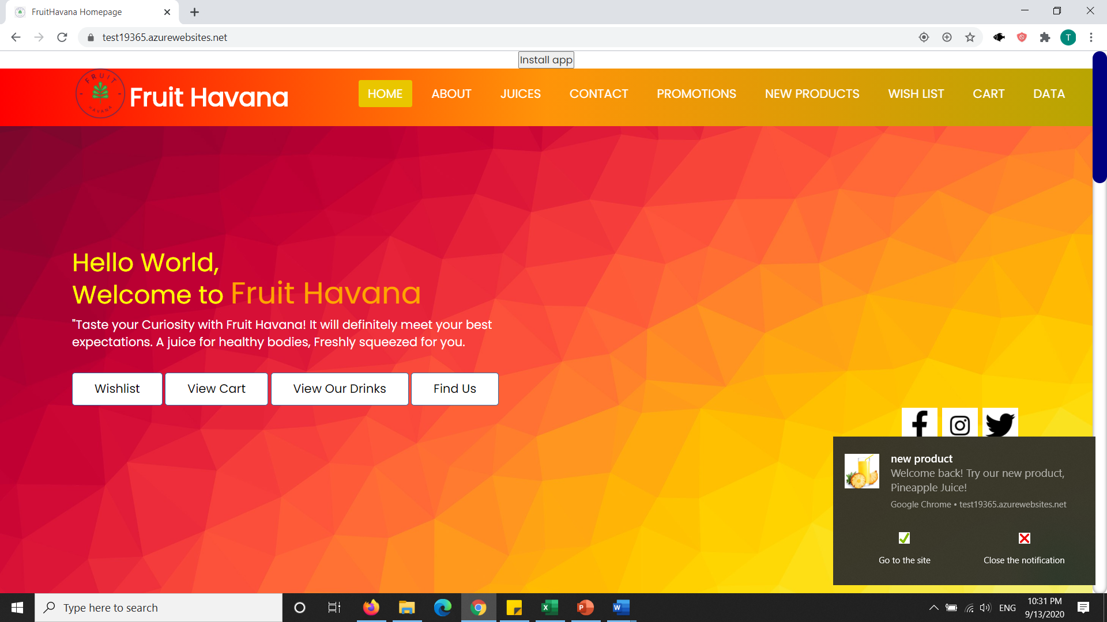

As we can see from the above two photos, we have notifications enabled. The notifications are automatically generated by the service worker when the user first loads the website. The website has to be loaded twice, to wait for the code to run smoothly.

Then, when the user clicks into the notifications, it brings them to the respective web pages.

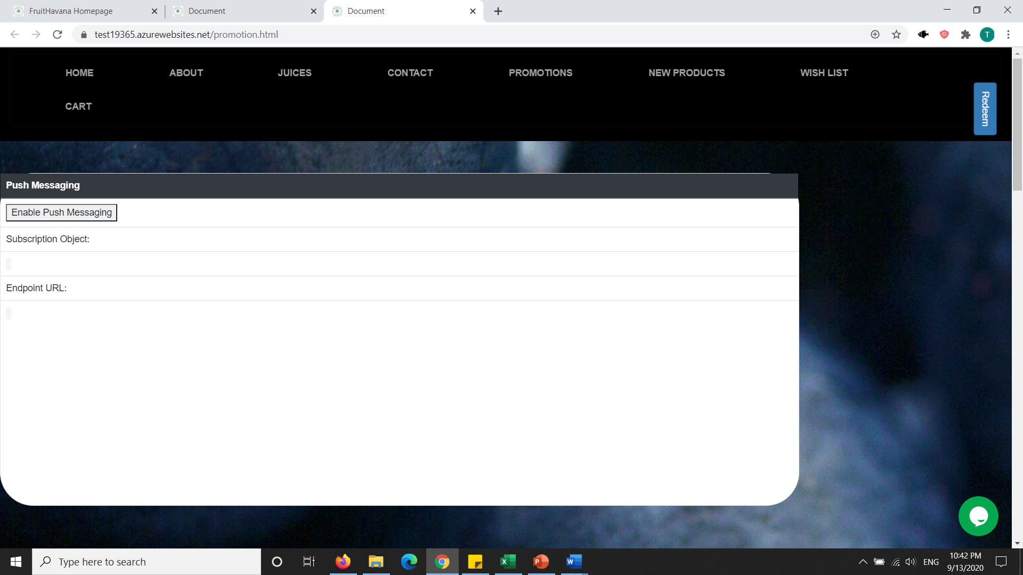

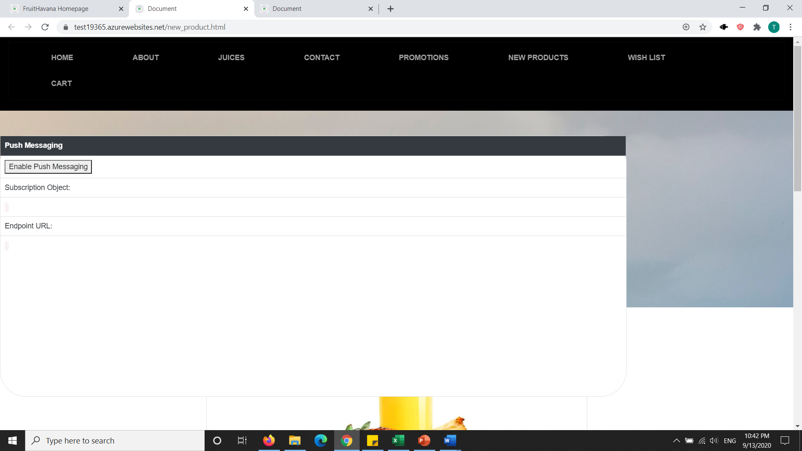

Both websites have push messaging enabled, and they can be subscribed and not subscribed whenever they want. The owner can also send notifications to the customer via firebase network or node js.

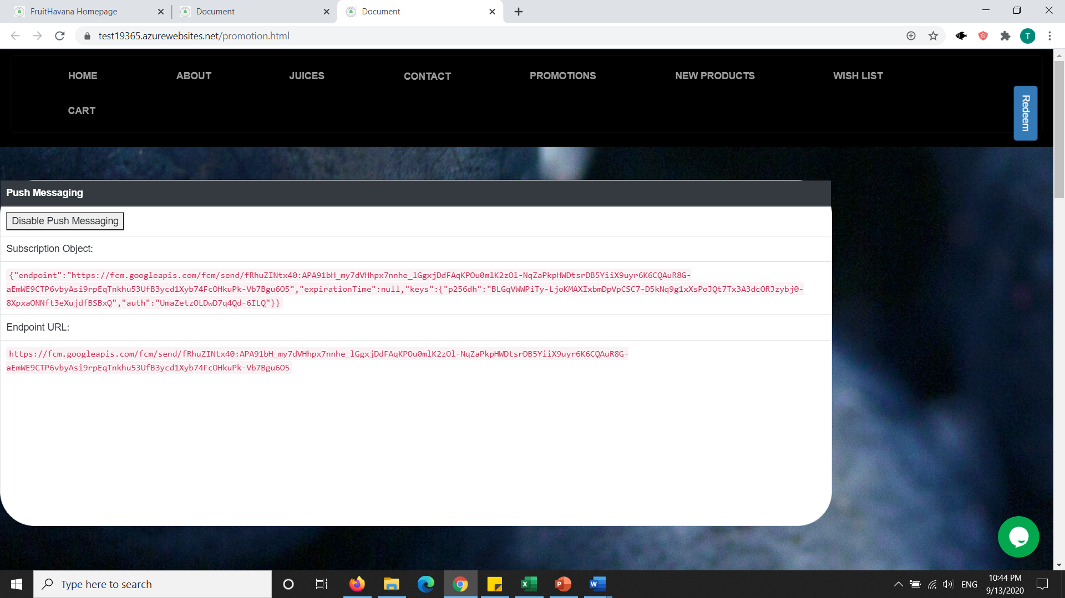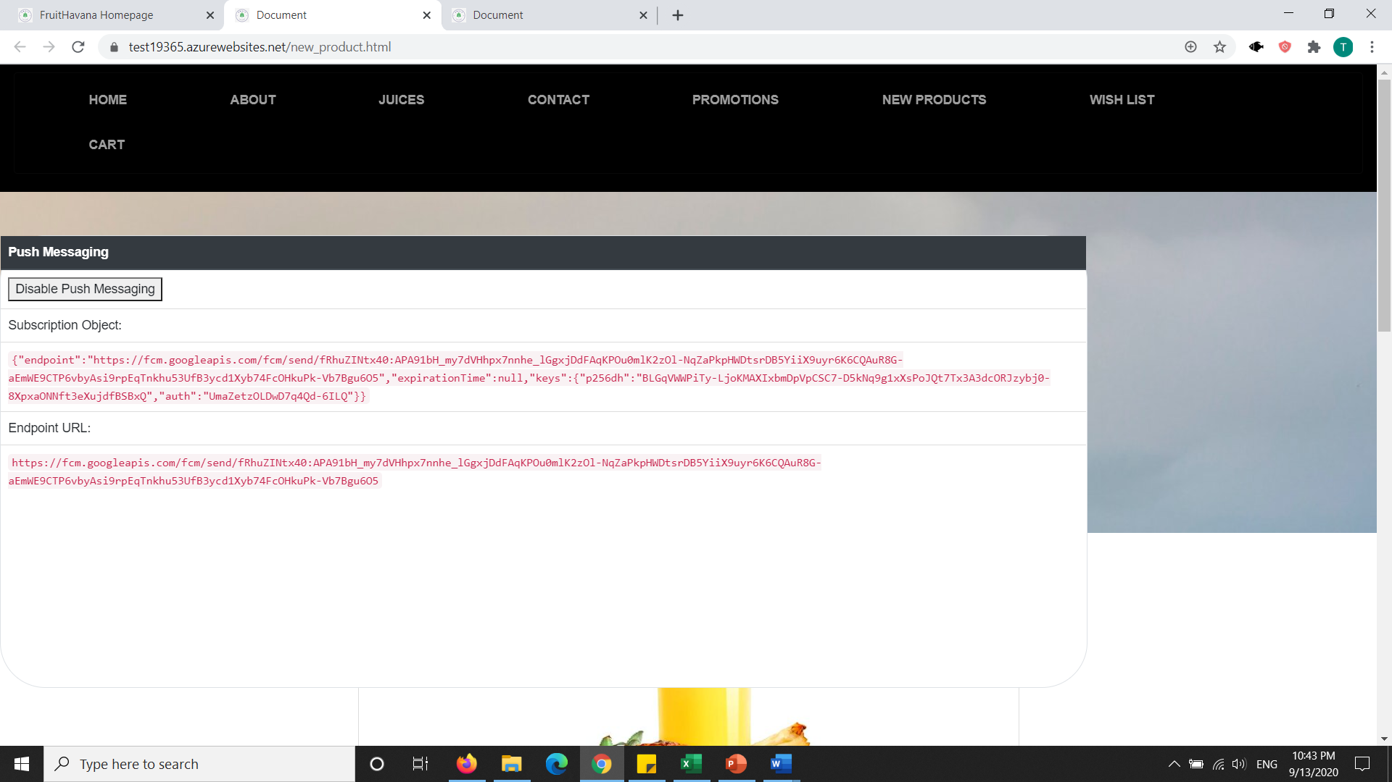

The above pictures have push messaging enabled.

**Promotions**

For promotions, it was directly corelated with notifications as seen from the images above. User can choose to subscribe to push notifications or not, and receive notifications from time to time.

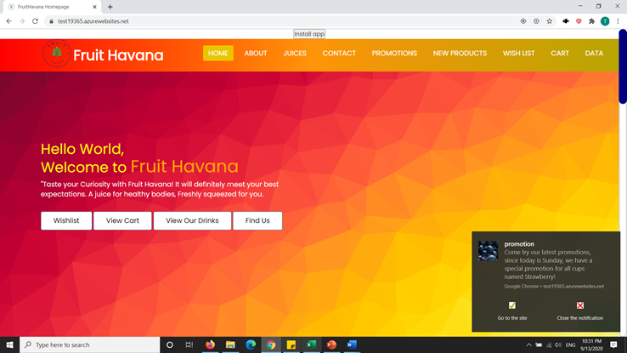

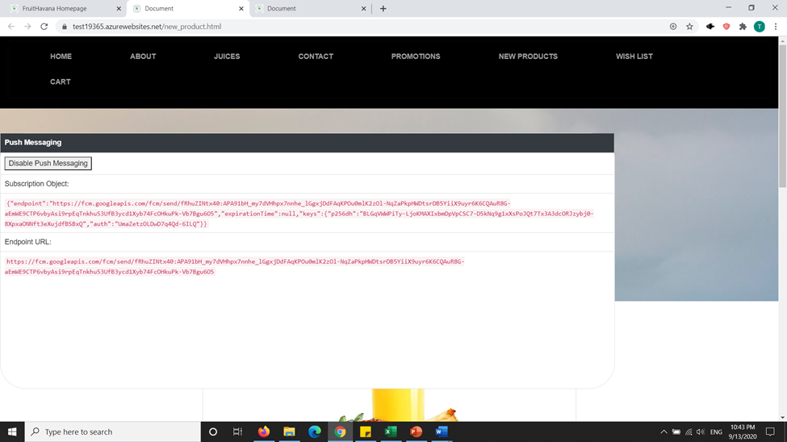

Furthermore, user can choose which promotions they wish to apply, and can get reduced offers for the drinks they order.

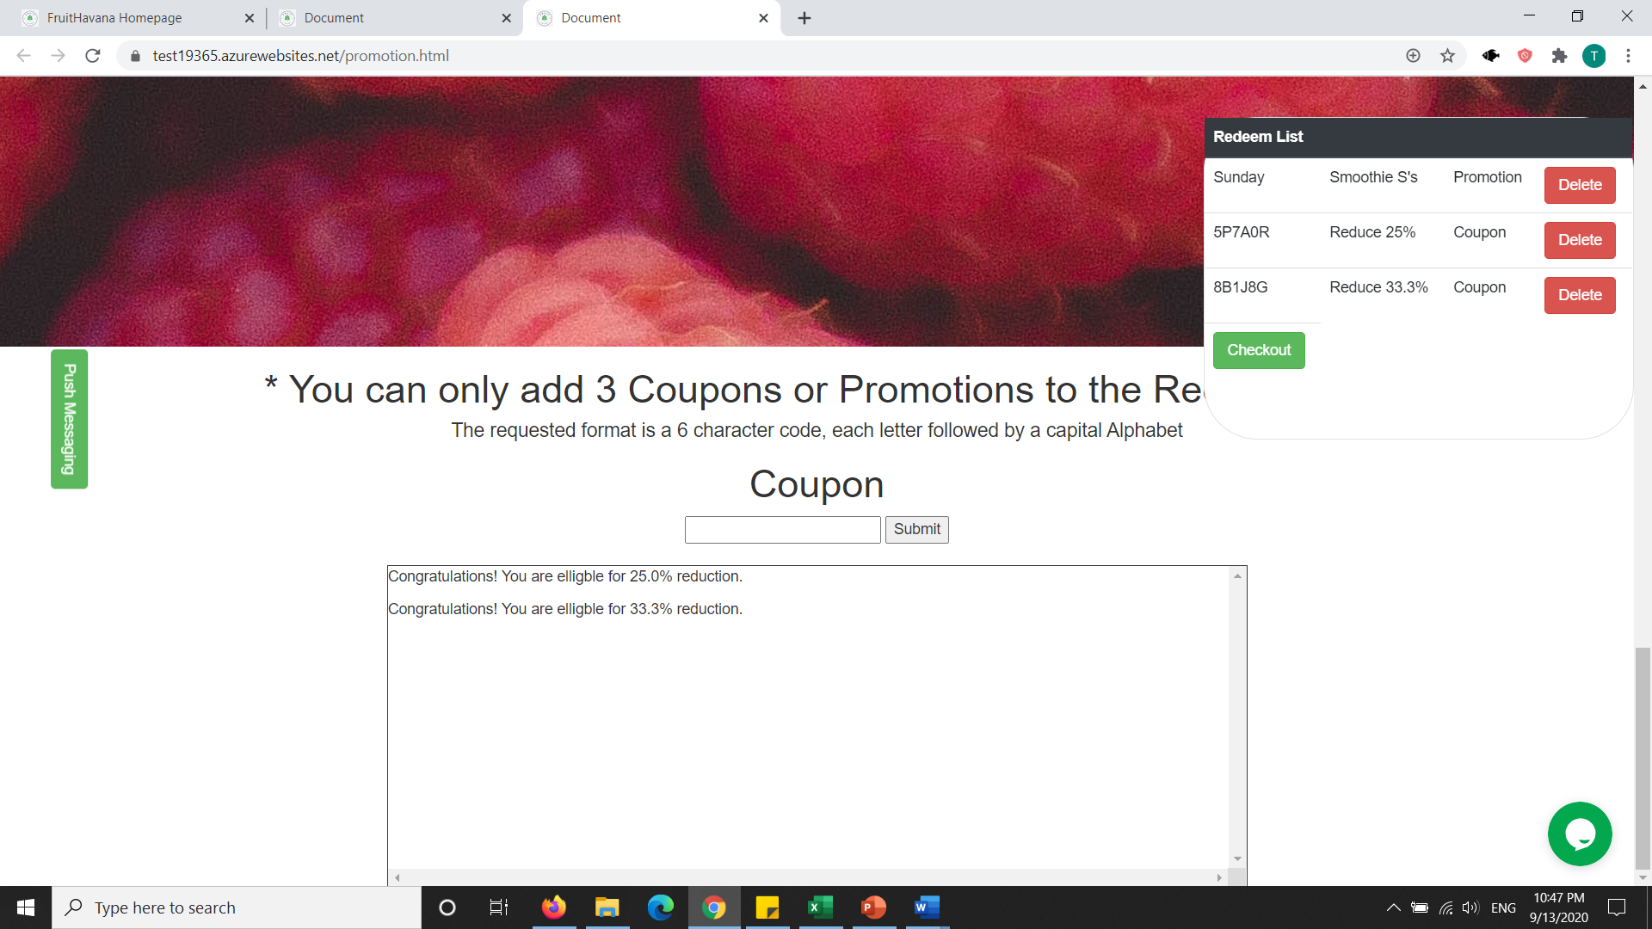

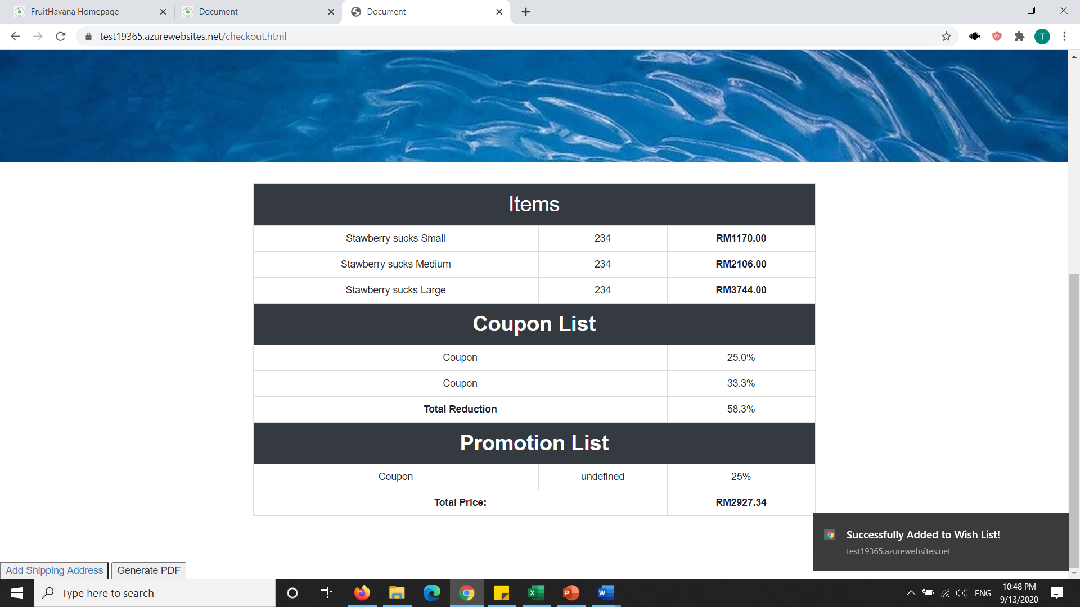

As, we can see, there is a reduction to the price of the beverages after applying the promotions. There are also coupons, which cannot be duplicated.

**New Products**







As we can see from the pages above, notifications are enabled for the new products, and user are alerted if any new products are added into the website. We can also send push notifications via node js or firebase network.

# **Chapter 5: Reference**

# **References**

**Chee Kin. (2020). *You Can Start Visiting Pasar Pagi & Pasar Malam But You NEED To Follow These SOPs!* Retrieved from Word Of Buzz: https://worldofbuzz.com/you-can-start-visiting-pasar-pagi-pasar-malam-but-you-need-to-follow-these-sops/**

**Mountain Fresh Fruit Juice Malaysia. (2020). *MOUNTAIN FRESH FRUIT JUICE*. Retrieved from Mountain Fresh: https://mountainfresh.com.my/**

**The Cool Juice Malaysia. (2017). *The Cool Cold Pressed Juice*. Retrieved from Cool Juice: https://thecooljuice.com.my/**

**Universal NutriBeverage Malaysia. (2020). *Universal Nutribeverage*. Retrieved from Nutribev Online: https://nutribevonline.com/index.php?route=common%2Fhome**

**Yuvaraj, A. (2020). *PASAR MALAM TRADERS STRUGGLING WITH STRICT SOPS*. Retrieved from BFM: The Business Station: https://www.bfm.my/podcast/enterprise/enterprise-biz-bytes/ent-bb-pasar-malam-trader-struggle-sops**